**Phenyl ester based homopolymers: promising photoactive substrates for spatial arrangement of block copolymer nanopatterns**

*Jiacheng ZhaoA,B, Francis Mccallum A,B, Peter Trefonas c, Hui Peng A,B, Andrew K. Whittaker A,B\**

*Corresponding Author: a.whittaker@uq.edu.au*

AAustralian Institute for Bioengineering and Nanotechnology (AIBN), The University of Queensland, Brisbane, Australia; BARC Centre of Excellence in Convergent Bio-Nano Science & Technology (CBNS), The University of Queensland, Brisbane, Australia; cDuPont Electronics & Imaging, Marlborough, USA.

**Abstract**

Spatial arrangement of block copolymer (BCPs) in thin films has potential applications in nanolithography and device manufacture due to its potential high throughput and low cost. To achieve perpendicular alignment of the BCPs, a so-called “neutral” surface, in which the interface energy between the substrate and two blocks of the BCPs are equal, is necessary. Our former work has demonstrated that photo-fries rearrangement of poly(4-acetoxystyrene) under UV (254 nm) irradiation is a versatile method for tuning surface energy of substrate to achieve a neutral layer.1 However, a high UV dose (2.5 ~ 2.7 J cm-2 ) as well as post-functionalization of irradiated area is required due to relatively low photo-fries rearrangement efficiency of poly(4-acetoxystyrene). In this work, we demonstrated a series of phenyl ester based homopolymers which can significantly change their surface energy (range from 27 mJ m-2 to 57 mJ m-2) when exposed to UV light with a low dose (< 1.2 Jcm-2). Upon exposure through photomasks and coating with polystyrene-*b*-poly(methyl methacrylate), well-defined micro-patterns consisting of perpendicularly oriented lamellar micro-domains were obtained.

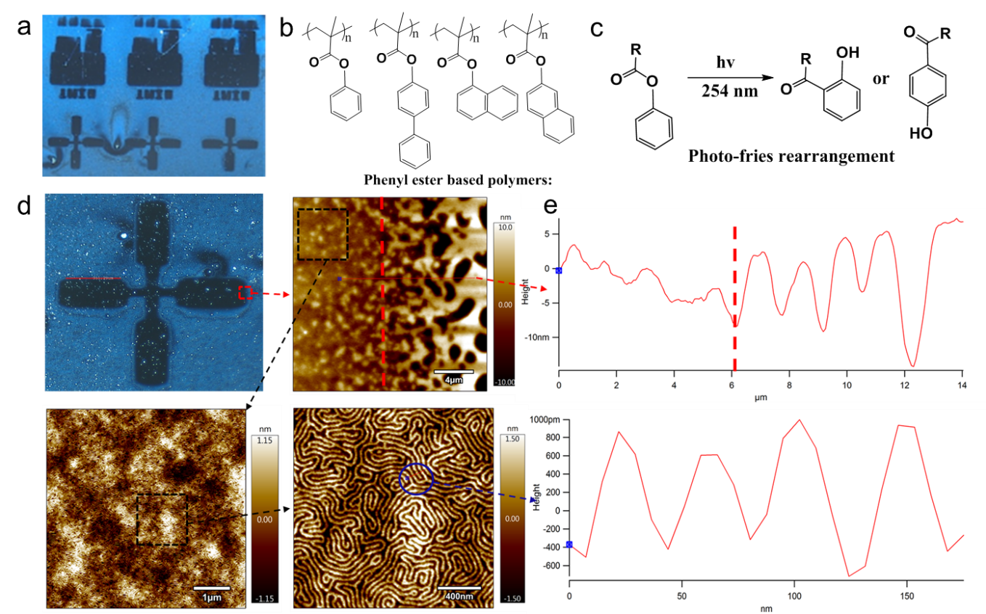

**Fig. 1.** a) Example of patterns prepared from phenyl ester based polymers; b) structures of phenyl ester based polymers; c) schematic illustration of photo-fries rearrangement; d) AFM images of zoomed-in area of the macro-patterns; e) height of the boundary (top) and lamellar structures (down).

**References**

1. Zhen, J. & Alam, M. (2019). Spatial arrangement of block copolymer nanopatterns using a photoactive homopolymer substrate. Nanoscale Adv., 1, 3078-3085.