Associations of blood pressure parameters with cognitive decline and dementia: umbrella review
Sultana Shajahan¹, Megan Heffernan¹, Katie Harris¹, Cheryl Carcel¹, Mark Woodward^{1,2}, Craig S. Anderson^{1,3}, Ruth Peters¹. The George Institute for Global Health, UNSW¹, Sydney, NSW, Australia; TGI UK, Imperial College London², Sydney, NSW, Australia; Institute of Sci and Tech for Brain-inspired Intelligence, Fudan University³, Shanghai, China.
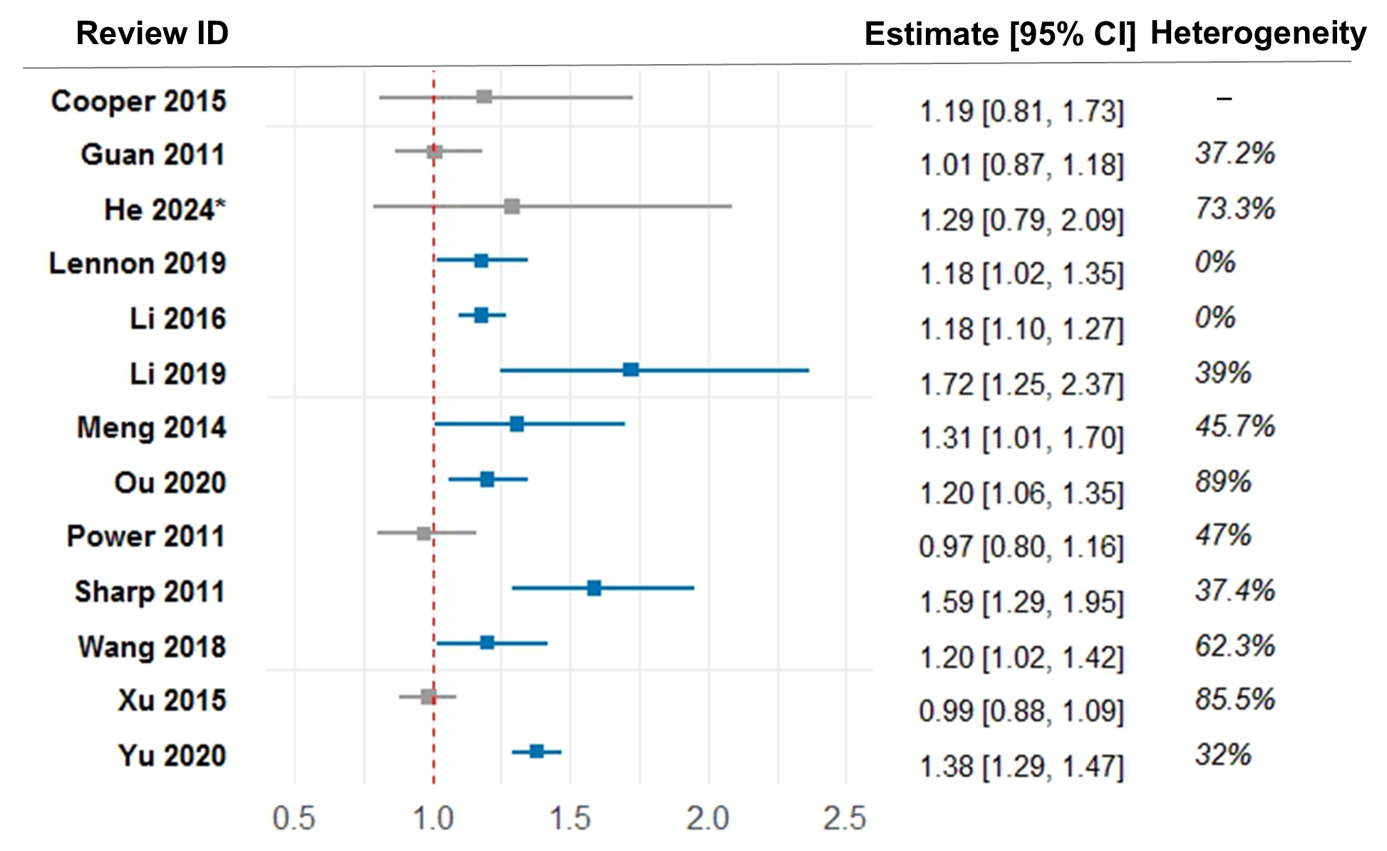
Introduction. Evidence syntheses on the associations between blood pressure (BP) parameters and cognitive decline and/or dementia have taken different methodological approaches and targeted different BP parameters and outcomes.
Aims. The aim of this umbrella review was to provide a high-level synthesis of published systematic reviews with meta-analyses on these associations.
Methods. PubMed, Embase, PsycINFO, and Cochrane were searched up to April 2025 for eligible reviews. Risk of bias was assessed using the AMSTAR-2 tool and overlap of constituent studies between reviews was explored.
Results. Among 31 included reviews, eight reported positive associations between higher BP and greater incidence of cognitive decline or dementia, five drew neutral conclusions, and one reported an inverse relationship. Greater mid-life BP was associated with greater risk of all-cause dementia, whereas late-life hypertension might have a mixed or overall neutral association. Three reviews reported associations between higher BP variability and all-cause dementia, and two for cognitive decline. Reviews also reported associations between higher pulse wave velocity and orthostatic hypotension and poorer outcomes. No reviews examined pulse pressure, mean-arterial pressure or cumulative BP load. Most reviews were of low quality, with considerable heterogeneity in BP parameter definitions and outcome criteria. Overlap of constituent studies for each BP parameter was low.
Discussion. In addition to high BP, incorporating variability, pulse wave velocity and orthostatic hypertension into risk assessments of cognitive decline or dementia and adopting standardized definitions for BP parameters and cognitive outcomes may improve comparability across future studies and strengthen clinical guidance.

