**Development and Validation Of A High Performance Thin-Layer Chromatography (HPTLC) Method For Analyzing Caffeine In Saliva For CYP1A2*1F Phenotyping**

**K M Yasif K Sikdar1**, Samara R Coverley1,2, Md K Islam1, Okhee Yoo1,3, Philip Burcham1,2, Lee Yong Lim1,3, Cornelia Locher1,3.

1Division of Pharmacy and Centre for Optimisation of Medicines, The University of Western Australia, Crawley, WA 6009, Australia;

2Division of Pharmacology and Toxicology, The University of Western Australia, Crawley, WA 6009, Australia;

3Institute for Paediatric Perioperative Excellence, The University of Western Australia, Crawley, WA 6009, Australia.

**Background and aims.** CYP1A2*1F plays a critical role in the metabolism of various drugs such as clozapine, propranolol and warfarin. Caffeine is the probe drug of choice for CYP1A2*1F phenotyping. Due to the non-invasive nature of sampling, saliva is an alternative biofluid to plasma for monitoring caffeine levels. This study aims to develop and validate a HPTLC method for quantifying salivary caffeine levels and to demonstrate its value in CYP1A2*1F phenotypic assessments.

**Methods.** A HPTLC method using silica gel 60 F254 plates and acetone: toluene: chloroform (4:3:3, *v/v/v)* as mobile phase was developed and validated in accordance with International Council for Harmonisation (ICH) guidelines. An optimised saliva processing protocol using a 1:1 dilution with methanol was also established. 20 clinical saliva sample sets collected 0-4 h after ingestion of 100 mg caffeine were analysed using this approach. Following PCR-RFLP genotyping, measured saliva caffeine concentrations were used to develop a population pharmacokinetic (PK) model to demonstrate differences in caffeine clearance between genotypes (AA, AC, CC) and to assess CYP1A2*1F activity.

**Results.** The developed HPTLC method separated caffeine from its major metabolites (Figure 1) with detection and quantification limits of 2.42 and 7.34 ng/band respectively. Salivary caffeine levels peaked at 1 h and then gradually decreased (Figure 2). Based on the developed PK model, the AC and CC genotypes demonstrated slower caffeine clearance than the AA genotype by factors of 0.68 and 0.70, but no statistically significant difference in clearance was detected between AC and CC.

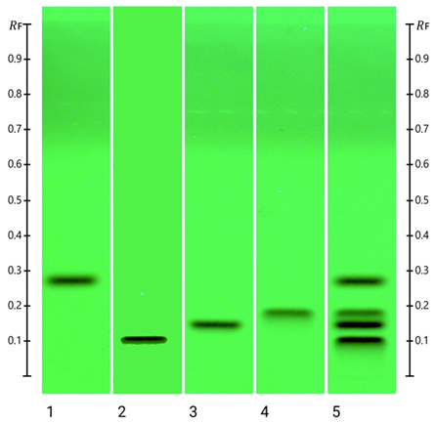 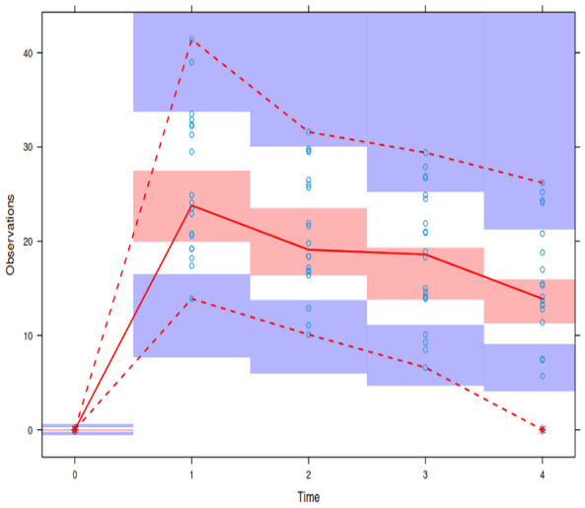

**Figure 1.** HPTLC fingerprint (254 nm): 1-caffeine, 2-paraxanthine,

3-theobromine, 4-theophylline, 5-mixture

**Figure 2.** Visual predictive checks for salivary caffeine concentrations

**Conclusion/Discussion.** The findings of this study demonstrate the value of a HPTLC-based analysis of salivary caffeine which can be used to determine CYP1A2*1F activity and therefore to support pharmacogenomic assessments.

**References:** This research was conducted during the author receipt of an International Fee Scholarship and a University Postgraduate Award from the University of Western Australia.

(1) Fenske, M. (2007) Chromatographia 65: 233-238

(2) Oellig, C. et al (2018) Journal of Chromatography A 1533: 208-212

(3) Sachse, C. et al (1999) British journal of clinical pharmacology 47:445-449