***In Vivo* Evaluation of Cationic Polycatenane as Intracellular Delivery Carrier for Biopharmaceuticals**

**Taishi Higashi**1, Toru Taharabaru1, Keiichi Motoyama1.

Graduate School of Pharmaceutical Sciences, Kumamoto University1, Kumamoto, Japan.

**Background and aims.** Recently, interlocked supermolecules, such as polyrotaxanes and polycatenanes, have attracted considerable attention, and cyclodextrins (CyDs) are often used as building blocks. There have been many studies applying CyD polyrotaxanes to functional materials such as biomaterials, but none of them have been applied using CyD polycatenanes because of the difficulty in preparing polycatenanes. We have previously prepared CyD polycatenanes using β- or γ-CyD as cyclic compounds and Pluronic as an axile molecule1-3). In addition, we recently prepared α-CyD polycatenane through the condensation of two polypseudorotaxanes, precursor of polycatenane. Moreover, we developed aminated polycatenane and preliminarily evaluated it as intracellular delivery carriers for biopharmaceuticals such as siRNA and Cas9 ribonucleoprotein (Cas9 RNP)4). In the present study, potentials of aminated polycatenane as intracellular delivery carriers were evaluated both *in vitro* and *in vivo*.

**Results and discussion.** To prepare polycatenane, polypseudorotaxanes consisting of α-CyD and amino- or carboxyl-terminated polyethylene glycol (PEG) were prepared. Then, both polypseudorotaxanes were condensed by BOP reagent/1-hydroxybenzotri-azole/N-ethyldiisopropylamine (**Figure 1**). Formation of the polycatenane was confirmed by 1H-NMR spectrum. To prepare the cationic polycatenane, diethylenetriamine (DET) was modified to the resulting polycatenane. Interestingly, DET-modified cationic polycatenane (DET-PCn) was efficiently formed complexes with biopharmaceuticals such as Cas9 RNP and siRNA. Moreover, the intracellular delivery efficiency of cationic polycatenane was greater than that of DET-modified cationic polyrotaxane (DET-PRX). Most importantly, antitumor siRNA complex with DET-PCn showed stronger antitumor effects than the complex with DET-PRX *in vivo*. Furthermore, DET-PCn/Cas9 RNP complex showed stronger *in vivo* genome-editing effects than DET-PRX/Cas9 RNP complex in the brain after stereotactic injection.

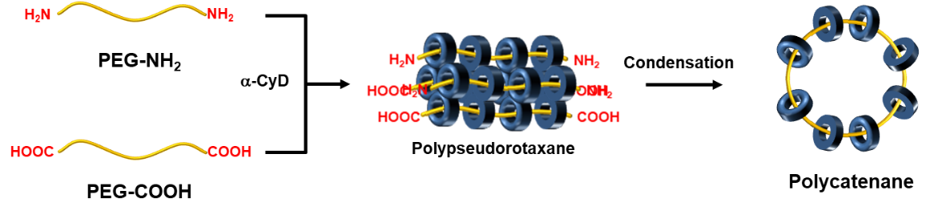

**Figure 1. Preparation of polycatenane via condensation of two polypseudorotaxanes.**

**Conclusion.** Cationic polycatenane has potentials as promising drug delivery carriers for biopharmaceuticals both *in vitro* and *in vivo*.

**References:**

(1) T. Higashi, *et al*., ***Commun. Chem.***, 2, 78 (2019).

(2) K. Morita *et al.*, ***J. Incl. Phenom. Macrocycl. Chem.***, 100, 169-175 (2021).

(3) T. Higashi, *et al*., ***Carbohydr. Polym.***, 337, 122143 (2024).

(4) T. Higashi *et al.*, ***AFPS 2023***, Hanoi, Viet Nam (2023).