Trauma informed medical care supports opioid stewardship in Aboriginal Medical Services, NSW Australia.
David A Skalicky¹. Durri Aboriginal Medical Service, Kempsey, NSW, Australia.
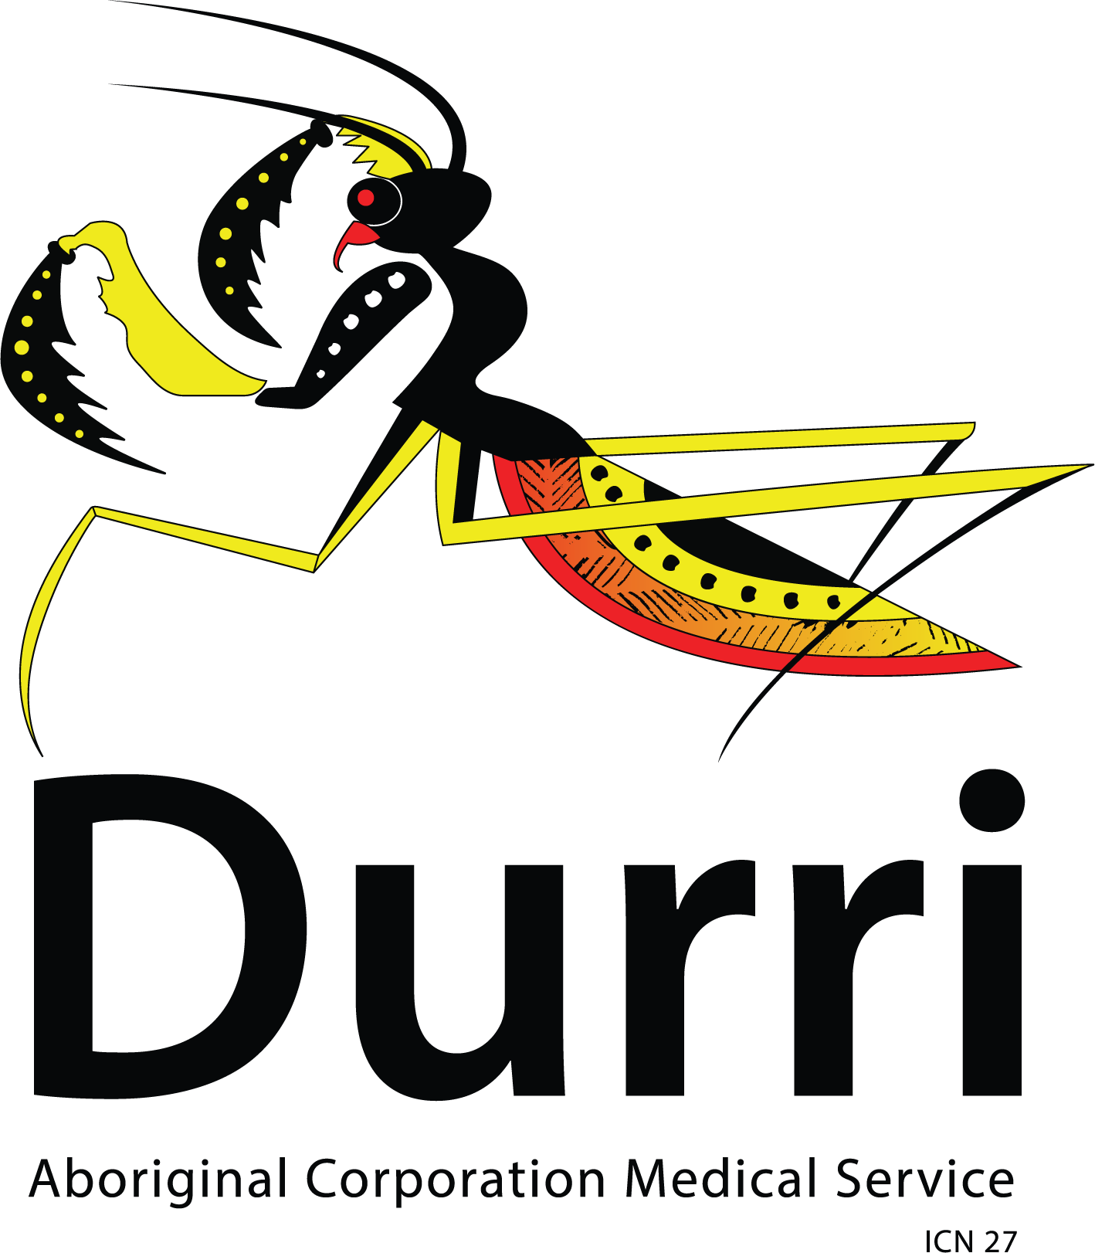
Introduction. Aboriginal Communities trust their Aboriginal Medical Services (AMS) to provide trauma informed, holistic health care. Medication management, including prescribing opioids, whose harm is often greater than their benefit in chronic pain, is important in primary care.

Aims. To explore the contribution of trauma informed care as a support for the management of chronic pain, and opioid stewardship in Aboriginal Medical Services.

Methods. This retrospective study of a physician practitioner, reviewed clinical episodes with patients for the effect of trauma informed counselling on opioid stewardship and pain medicine prescriptions. Clinical notes and physician letters from the physician clinical episodes for three years 2023 - 2025 across two AMS sites in NSW, one face to face and another telehealth, were retrospectively reviewed for trauma informed counselling and opioid stewardship.

Results. Of the 228 clinical episodes for 136 patients showed that trauma informed counselling and opioid stewardship were provided together in almost all episodes. The benefits were reduced opioid use, and support for general practitioner prescribers in the primary care settings.

Discussion. Provision of trauma informed care complements a successful opioid stewardship program for Aboriginal Australians in a primary care setting.

- Dr David Skalicky, visiting rehabilitation physician, Durri Aboriginal Medical Service, Kempsey, NSW. skalicky.david1@gmail.com
Do not change the margins, the font, size or any other setup on this template. The abstract should be left-and right-justified. Line spacing must be single. The abstract must be one A5 page only. The abstract must be typed in Calibri 10 point. Do not use bold in the abstract text, only the title should be in bold. As abstract pages may be printed in black and white only, you may consider including tables and images in greyscale. Please pay particular attention to these instructions as abstracts that do not conform will not be accepted by the editors.

The text should be as informative as possible. If you have any problems please call Expert Events on +61 7 3848 2100 or wcp2026@expertevents.com.au.

