**Sub-acute toxicity study of decoction extract and powder of Polygonum Multiflorum Radix (PMR) by 4-week repeated oral administration in** **Sprague-Dawley (SD) rats**

**Seung Eui Min1, 2**, Min Seong Jang2, Yong-Bum Kim2, Byung Sun Min3, Jeong Ah Kim4, and Kang-Hyun Han1, 2

1 Human and Environmental Toxicology, University of Science and Technology, 217 Gajeong-ro, Yuseong-gu, Daejeon, 34113, Republic of Korea,

2 Department of Advanced Toxicology Research, Korea Institute of Toxicology, 141 Gajeong-ro, Yuseong-gu, Daejeon, 34114, Republic of Korea,

3 College of Pharmacy, Daegu Catholic University, Gyeongsan, Gyeongbuk 38430, Republic of Korea,

4 College of Pharmacy, Kyungpook National University, Daegu 41566, Republic of Korea

**Background and aims.** Polygonum Multiflorum Radix (PMR) is a traditional herbal medicine native to China and has been traditionally used in Asia for its various biological activities, including tonic properties and hair blacking. There are various extraction methods for PMR; decoction extract and powder form are mainly used. However, toxicity information on these PMR decoction extracts and powders is lacking, so toxicity studies are needed. This study presents the results of a 4-week repeated administration of two test substances for long-term toxicity study.

**Methods.** Test substances were orally administered to SD rats of both sexes at doses of 0, 250, 500, 1000, 2000, and 5000 mg/kg/day for 4 weeks. Mortality and clinical signs were observed, as well as body weight, food consumption, hematology, clinical chemistry, organ weight, and macroscopic findings.

**Results.** As a result of the study, no test item-related mortality, clinical signs, body weight changes, food consumption, hematology, clinical chemistry, organ weight changes, and macroscopic findings were observed. As a result of clinical sign observation, soft feces and soiled perineal regions were observed in male 2000 mg/kg/day and in both sexes of the 5000 mg/kg/day of PMR decoction extract. Soft feces and salivation were observed in male 2000 mg/kg/day and in both sexes of the 5000 mg/kg/day of PMR powder, respectively. However, these clinical signs were not considered to be severe adverse effects, although they were associated with the administration of the two test substances (Table 1).

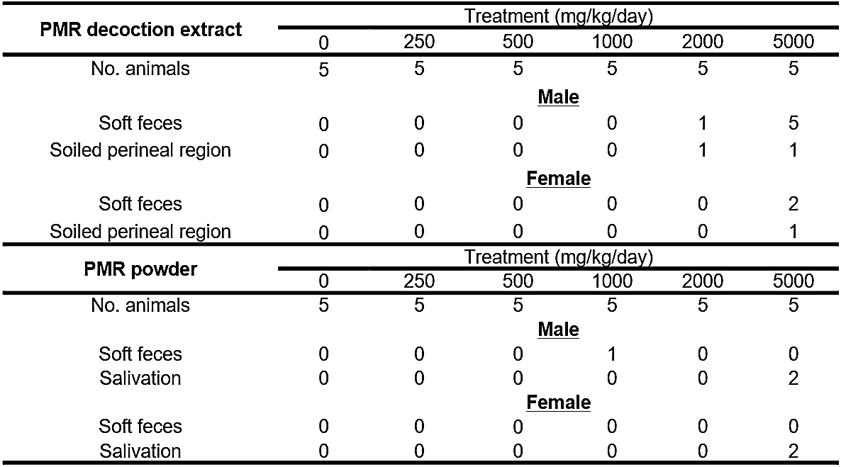

**Table 1.** Clinical signs in a 4-week repeated-dose toxicity study with PMR decoction extract and PMR powder.

**Conclusion/Discussion.** Therefore, it is recommended that the high dose for the 13-week repeated oral administration toxicity study of both PMR decoction extract and powder be less than 5000 mg/kg/day.

**References:** Acknowledgements: Founding source - This research was funded by grants from the Ministry of Food and Drug Safety (23212MFDS204) and the Korean Ministry of Environment (MOE) (RS-2022-KE002112;2480000626).