**Phage-Loaded Liposomal Inhalation Therapy For Drug-Resistant Lung Infections**

*Jesil Mathew Aranjani, Rafwana Ibrahim  
Department of Pharmaceutical Biotechnology, Manipal College of Pharmaceutical Sciences, Manipal Academy of Higher Education, Manipal, Karnataka, India*

**Background and Aims.** The alarming rise in multidrug-resistant Pseudomonas aeruginosa infections, particularly in pulmonary settings, has necessitated alternative antimicrobial strategies beyond conventional antibiotics. Bacteriophage therapy is gaining renewed interest due to its precision in targeting bacterial pathogens without disturbing host microbiota. However, challenges such as phage instability, immune clearance, and limited residence time in the lungs hinder its clinical application. This study aimed to develop a liposomal delivery system encapsulating a phage cocktail to enhance its pulmonary stability and therapeutic potential for inhalation-based therapy.

**Methods.** A broad-spectrum phage cocktail active against drug-resistant *P. aeruginosa* clinical isolates was generated through sequential enrichment, plaque purification, and host-range screening. Morphological and genomic analyses confirmed lytic nature and absence of undesirable genes. Phages were encapsulated in liposomes composed of phosphatidylcholine, cholesterol, DSPE-PEG, stearylamine, and Tween 80 via thin-film hydration and extrusion. Lipid ratios and process variables were optimized using Design of Experiments: a mixture design defined component proportions, followed by a Box–Behnken design to refine vesicle size, zeta potential, and encapsulation efficiency. The optimized liposomal formulation will be lyophilized with trehalose and leucine to obtain a stable dry-powder inhalation product.

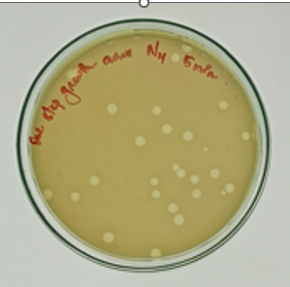 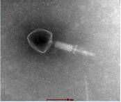 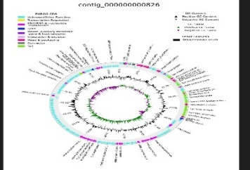

**Figure 1.** Characterization of bacteriophages: plaque morphology, TEM imaging, and lytic spectrum.

|  |  |  |  |
| --- | --- | --- | --- |
| Feature | *Pseudomonas phage SW_PA2862_7_24* | *Pseudomonas phage SW_PA2862_11_24* | *Pseudomonas phage SW_PA2862_14_24* |
| Genome Size | 92,798(bp) | 92,798(bp) | 92,799(bp) |
| ORF Count | 202 | 203 | 202 |
| Key Features Identified | Endolysin, Holin,Terminase, HNH Endonuclease, base plate, Head fiber | Tail Fiber Protein, DNA Packaging ATPase. Endolysin | Endolysin, Holin, Terminase, Tail Fiber Protein, DNA Packaging ATPase |
| GC Content (%) | 49.35 | 49.35 | 49.35 |

**Table 1:** Genomic characterization of phages

**Conclusion/Discussion.** By combining phage therapy with nanotechnology and rigorous DoE-guided optimization, this liposomal system is designed to enhance phage stability, evade immune neutralization, and achieve efficient lung deposition. The final dry-powder formulation aligns with AFPS 2025 themes of innovative drug-delivery technologies and offers a promising approach against drug-resistant pulmonary infections.

**References:**

1. Malik DJ et al. Formulation and stability of bacteriophage powders for inhalation. *Eur J Pharm Biopharm* 2017;121:1–13.
2. Abedon ST et al. Phage treatment of human infections. *Bacteriophage* 2011;1(2):66–85.

**Acknowledgements.** We thank Manipal Academy of Higher Education for the support.