Heart failure exacerbates renal medullary hypoxia and risk of acute kidney injury after cardiopulmonary bypass
Clive N. May¹, Anton Trask-Marino¹, Taku Furukawa¹, Ian Birchall¹, Lachlan F. Miles^{1,2}, Sally G. Hood¹, Connie Pei Chen Ow¹, Lindsea C. Booth¹, Yugeesh R. Lankadeva¹. ¹Preclinical Critical Care, Florey Institute of Neuroscience and Mental Health, University of Melbourne, VIC, Australia; ²Department of Anaesthesia, Austin Health, VIC, Australia.

Introduction. Acute kidney injury (AKI) is a major complication of cardiac surgery, especially in patients with heart failure (HF). Mechanistic insight has been limited by the lack of clinically relevant models.
Aims. To determine how pre-existing HF affects renal oxygenation and function before, during and after cardiopulmonary bypass (CPB), and to identify the mechanisms underlying postoperative AKI.
Methods. Female sheep were surgically instrumented under isoflurane anaesthesia (2.0-2.5% in oxygen-air mixture), for continuous monitoring of renal blood flow (RBF), renal oxygen delivery (RDO₂), renal cortical and medullary tissue oxygenation (PO₂) and urine output during 3 phases: pre-CPB (conscious), during CPB (anesthetized), and post-CPB (conscious). HF was induced via progressive coronary ligation and defined by a ≥25% fall in ejection fraction. HF (n=10) and control (n=10) animals underwent 2-h CPB with aortic cross-clamp followed by 48-h recovery.
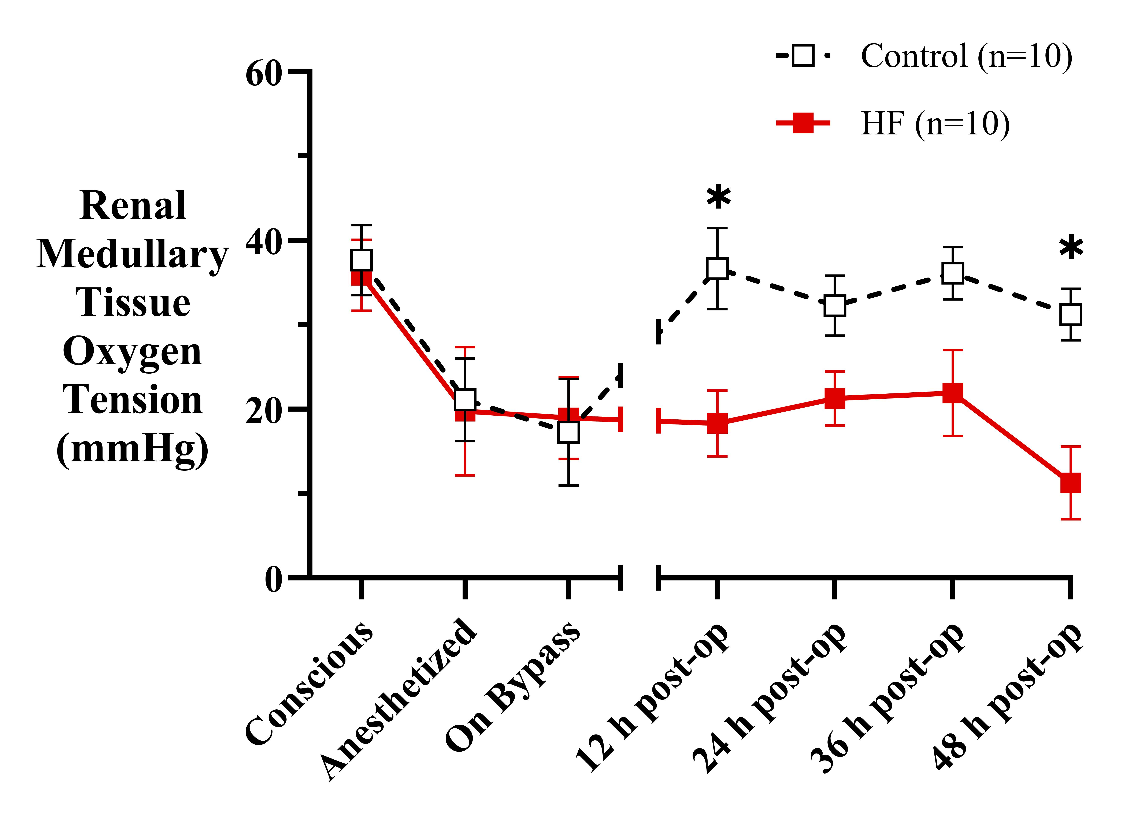
Results. CPB reduced RBF and renal medullary (but not cortical) tissue PO₂ in both groups (all P_{time} ≤0.001). Postoperatively, medullary PO₂ recovered in healthy controls but remained suppressed in sheep with HF (P_{group} <0.001), despite a similar recovery of RBF. Animals with HF also had persistently lower haemoglobin and RDO₂ across the perioperative phase (both P_{group} ≤0.05). In the HF group, postoperatively urine output was lower (P=0.039) and AKI occurred more frequently (50% vs. 11%; OR 9.0, P=0.14). Histopathology showed acute tubular necrosis and peritubular inflammation after CPB (50% [HF] vs. 37% [control]), with no group differences.
Discussion. Pre-existing HF amplifies renal vulnerability to CPB by preventing recovery of renal medullary oxygenation, implicating sustained tissue hypoxia as a driver of postoperative AKI and a potential target for renoprotection.

