**Toward the efficient electrochemical synthesis of H2O2 through the surface modification of carbon nanotubes embedded with atomic Co-Nx sites**

*Q. Zhang, X LuA,*, and R. AmalA,\**

AParticles and Catalysis Research Group, School of Chemical Engineering, The University of New South Wales, Sydney, NSW 2052, Australia

**Abstract**

Hydrogen peroxide (H2O2) produced by electrochemical oxygen reduction reaction (ORR) provides a potentially cost effective and energy efficient alternative to the industrial anthraquinone process.1 The large-scale deployment of such systems requires the development of highly active and selective catalysts with low cost. More importantly, the production of water needs to be suppressed during this reaction, and that is rarely achieved for most ORR electrocatalysts. Very recently, carbon-based materials have emerged as active catalysts to replace the precious-metal-based benchmarks (e.g. PtHg) for the electrosynthesis of H2O2 due to their easily tunable electronic structure and low cost.2 Nevertheless, most of these catalysts can only catalyze a decent H2O2 productivity in alkaline media, which is not favoured by the practical applications due to the easily decomposable property of H2O2 in alkaline. Moreover, large amounts of overpotential (>400 mV) are normally associated with these materials to achieve high productivity and selectivity, which has rendered the production process energy inefficient.3 Therefore, the development of highly selective and active catalysts with low cost for electrolytic H2O2 production in acids is highly sought after. In this study, we demonstrate that by modulating the surface chemical properties near the atomically dispersed Co sites with proper treatments, a highly active and selective ORR process for H2O2 production can be obtained in acidic electrolyte (Figure 1), showing a negligible amount of onset overpotential and nearly 100% selectivity within a wide range of applied potentials. Combined spectroscopic results reveal that the exceptionally enhanced performance of H2O2 generation originates from the precisely modified electronic structure of the Co-N4 centers. Computational modeling demonstrates these electronically modified Co atoms will enhance the H2O2 productivity during ORR in acid, providing new insights into the design of electroactive materials for effective peroxide production.

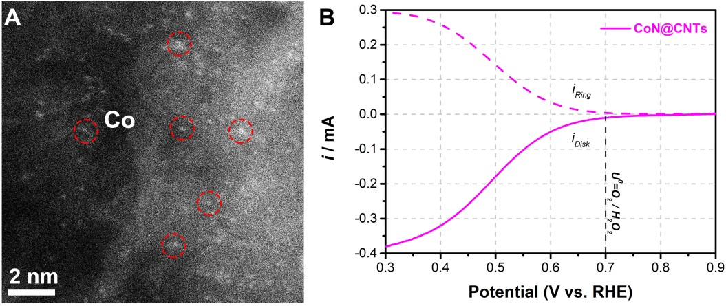

Figure 1. (A) The HAADF-STEM image of the CoN@CNTs showing many Co atoms (circled in red) well-dispersed in the carbon layers. (B) RRDE voltammograms of CoN@CNTs at 1600 rpm in an O2-saturated 0.1 M HClO4 electrolyte with disc current and ring current.

**References**

1. Zheng, Z., Ng, Y. H., Wang, D. W. & Amal, R. (2016). Epitaxial Growth of Au–Pt–Ni Nanorods for Direct High Selectivity H2O2 Production. Adv. Mater. 28, 9949–9955.
2. Lu, Z. et al. (2018). High-efficiency oxygen reduction to hydrogen peroxide catalysed by oxidized carbon materials. Nat. Catal. 1, 156–162.
3. Fellinger, T. P., Hasché, F., Strasser, P. & Antonietti, M. (2012). Mesoporous nitrogen-doped carbon for the electrocatalytic synthesis of hydrogen peroxide. J. Am. Chem. Soc. 134, 4072–4075.

*Corresponding author: xunyu.lu@unsw.edu.au, r.amal@unsw.edu.au