**A novel laser extinction device for rapid aerosol measurements exiting inhaler devices**

**Liam Milton-McGurk1, 2**, **Athiya Azeem3**, Shaokoon Cheng1,3, Agisilaos Kourmatzis2,3, Hak-Kim Chan2,4

School of Engineering, Macquarie University, Sydney, NSW, Australia1;

School of Aerospace, Mechanical and Mechatronic Engineering, The University of Sydney, Sydney, NSW, Australia2;

ASK Scientia Pty Ltd, Sydney, NSW, Australia3

Sydney Pharmacy School, The University of Sydney, Sydney, NSW, Australia2;

**Background and aims.** Characterising aerosols is an important problem with widespread applications across the pharmaceutical industry, particularly in the context of oral and nasal drug delivery. Traditional methods for analysing these systems can be expensive, time consuming, and are typically unable to provide transient information on the flow. This work introduces a lightweight, portable, laser-based device to measure transient light-attenuation through aerosols, allowing quantities such as velocity, turbulence and plume duration to be obtained. In this study, the device is applied to aerosols exiting commercial inhalers to investigate the extent to which the results may complement more traditional measurement techniques used in pharmaceutical research and industry.

**Methods.** The system consists of lasers mounted inside a compact ‘ring’ shaped casing designed to fit around the inlet of common mouth-throat models, such as the United States Pharmacopeia (USP) induction port. Light signals being attenuated are then analysed based on a proprietary algorithm to produce measurements such as particle velocity, turbulence and plume duration.

**Results.** Figure 1(a) shows a graphical image of the device, and figure 1(b) shows the plume duration computed from processed signals obtained from a prototype version. This corresponds to the time taken for the aerosol plume to pass through the device, and is related to the flow velocity and evacuation time of powder exiting the inhaler. The data shown corresponds to the dry powder inhalers (DPIs), the ‘Advair Diskus’ and the ‘Wixela Inhub’ (its generic alternative) run at 60 LPM. In this data (n=3), the Wixela Inhub has greater variability in its plume duration, and a median approximately 10% higher, than the Advair Diskus.

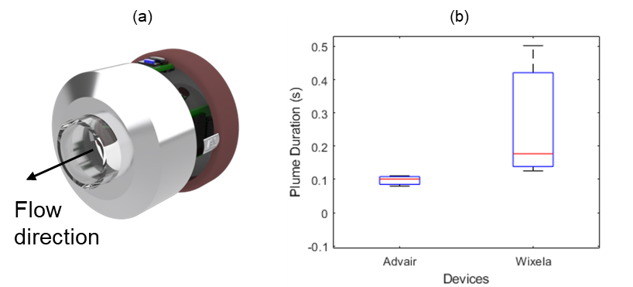

**Figure 1.** (a)Graphical image of the device, and, (b) box and whisker plots of the plume duration for the Advair Diskus and Wixela Inhub at 60 LPM, obtained from a prototype version of the device.

**Conclusion.** The device (patent pending) is capable of capturing the transient behaviour of aerosols as they leave inhaler devices and enter (or exit) airway models, allowing quantities such as velocity, plume duration, as well as other metrics to be obtained from the light signals. These quantities, and other metrics computable from the signal, may be correlated with, and thus potentially used to predict downstream aerosol behaviour which would be obtained from more time consuming instruments.