Cryo-EM structure of monomeric CXCL12-bound CXCR4 in active state
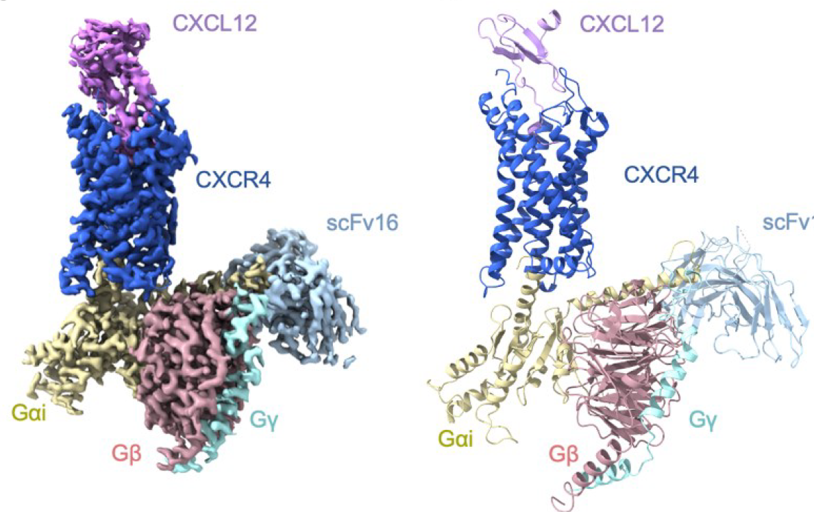
Yezhou Liu^{1,*}, Aijun Liu^{1,2,*}. Xinyu Li³, Qiwen Liao¹, Weijia Zhang¹, Lizhe Zhu³, Richard D. Ye^{1,4} Kobilka Institute of Innovative Drug Discovery, School of Medicine, The Chinese University of Hong Kong¹, Shenzhen, Guangdong, China; Dongguan Songshan Lake Central Hospital, Dongguan Third People's Hospital². Dongguan, Guangdong, China; Warshel Institute for Computational Biology, School of Medicine, The Chinese University of Hong Kong³, Shenzhen, Guangdong, China; *Equal contribution to this work.

Introduction. CXCR4 binding of CXCL12 leads to diverse functions including bone marrow retention of hematopoietic progenitors and cancer metastasis. However, the structure of a CXCL12-bound CXCR4 remains unresolved despite available structures of CXCR4 in complex with small molecule antagonists and a viral chemokine.
Aims. This work uses cryo-EM to solve the structure of CXCR4 bound to its endogenous agonist CXCL12.
Methods. A cryo-EM structure of CXCL12-CXCR4-Gi protein complex was obtained at 2.65 Å. Site-directed mutagenesis and functional assays were carried out to determine CXCR4-ligand interactions at chemokine recognition sites.
Results. CXCL12 forms a 1:1 stoichiometry complex with CXCR4, with its N-terminus inserting into the transmembrane (TM) binding pocket involving TM1/2/3/7. The first 8 amino acids of CXCL2 are crucial for activation of CXCR4 and interact with C186^{ECL2} and D187^{ECL2} through polar interactions and E288^{7.39} and D262^{6.58} through hydrogen bonding. The distance of 3.2Å between V3 and the ‘toggle switch’ W^{6.48} marks the deepest insertion among all chemokine-receptor pairs, leading to conformational changes of CXCR4 at the intracellular interface for G protein activation. Outside the TM pocket, CXCL12 binding is further stabilized through polar interaction of P10 with C28^{NT} of the PC motif of CXCR4.
Discussion. These results provide the structural basis for CXCR4 activation by CXCL12. CXCR4 activation in relation to its monomeric and higher-order structure will be discussed.

