TRACKER Biobank: empowering lung cancer breakthroughs
S. Shivakumar^{1,2,3,4}, N. Vukelic⁴, F. Atashrazm⁴, V. Naranbhai⁵, J. Da Gama Duarte^{4,5}, N. Goh^{1,2,3}, S. Parakh^{1,4} T. Leong^{1,2,3,4}
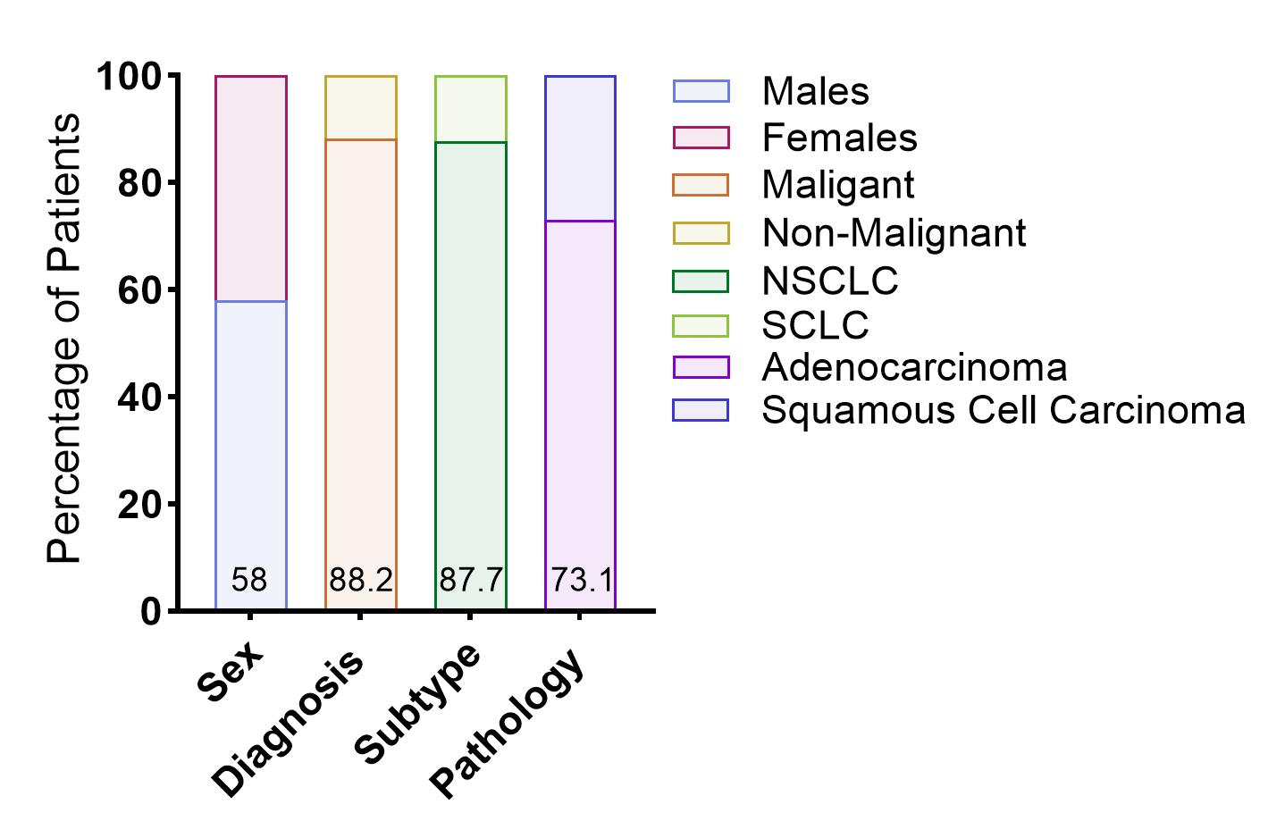
1 Austin health, VIC, 2 University of Melbourne, VIC, 3 Institute for Breathing and Sleep, VIC, 4 Olivia Newton John Cancer Research Institute VIC, 5Monash University, VIC
Introduction. Lung cancer is the leading cause of cancer death in Australia, with over half of cases diagnosed advanced stage. There remains a critical lack of biospecimens to drive breakthroughs in areas of unmet need, including immunotherapy resistance and treatment-related side effects.
Aims. TRACKER is a first-of-its-kind national biobank collecting biospecimens with clinical data from lung cancer patients at diagnosis, during treatment, and at progression. Multi-omic analysis will investigate biomarkers of immunotherapy resistance and checkpoint inhibitor pneumonitis. We report findings from the first 149 participants.
Methods. Patients were recruited at Austin Health (VIC), the Royal Melbourne Hospital (VIC), Macquarie University Hospital (NSW), St Vincent’s Hospital (NSW), and the Royal Adelaide Hospital (SA), with expansion planned across an additional six sites. Planned multimodal analyses include Whole Exome Sequencing, CITE-seq, FACS, metagenomics, and circulating tumour DNA.
Results. Of 149 participants (median age 65; 67.3% male), 81.6% had lung cancer, predominantly NSCLC (93.8%). Subtypes included adenocarcinoma (70.4%) and squamous cell carcinoma (25%). A total of 108 EBUS, and 256 longitudinal blood samples have been collected to date. Immunotherapy was received in 54.7% of patients; among those with response data, 70% showed early response and 30% primary resistance.
Discussion. Early findings confirm TRACKER’s feasibility and its value as a unique, longitudinal national biobank supporting innovative research with the potential to significantly improve lung cancer care and outcomes.
References
Australian Institute of Health and Welfare. Cancer in Australia 2021. Cancer Series 2021; 133.
Health AIo, Welfare. Lung cancer in Australia: an overview. Canberra: AIHW, 2011.

