**Lymph Node-Biomimetic Scaffold Boosts CAR-T Therapy Against Solid Tumor**

**Ziyan Liao1**, Hongjun Li1, Zhen Gu1.

College of Pharmaceutical Sciences, Zhejiang University 1, Hangzhou, China.

**Background and aims.** Chimeric antigen receptor (CAR)-T cell therapy has shown unprecedented success in treating hematologic malignancies. Still, limited clinical efficacy has been achieved in solid tumor treatments due to the dense extracellular matrix and the immunosuppressive tumor microenvironment of solid tumors. A three-dimensional scaffold, which mimics the porous bulk structure and biofunctions of lymph nodes, could enhance the delivery and expansion of CAR-T cells and improve their therapeutic effects on solid tumors.

**Methods.** The porous poly(lactic-co-glycolic acid) (PLGA) microspheres were fabricated via microfluidic technology and were functionalized with T-cell stimulatory anti-CD3 antibodies and co-stimulatory anti-CD28 antibodies signals, as well as cytokines, to mimic antigen-presenting cells within lymph nodes. A biomimetic scaffold was constructed of several microspheres.

**Results.** The average sizes of the pores and the scaffolds were 25 and 570 μm, respectively, thus allowing efficient loading of cells and injection of the scaffold directly into tumor sites without surgery. Each microsphere could load over 38000 CAR-T cells. The *in vitro* analysis demonstrated that the lymph node-biomimetic scaffold promoted a 50-fold expansion of CAR-T cells after three weeks. And the CAR-T cells activated via scaffold displayed reduced exhaustion markers. The *in vivo* bioluminescence imaging results demonstrated that the number of CAR-T cells delivered by scaffolds was 3-fold higher than that treated with free cells. Mice treated with scaffold-assisted CAR-T cells exhibited significant tumor suppression compared to direct CAR-T cell injection.

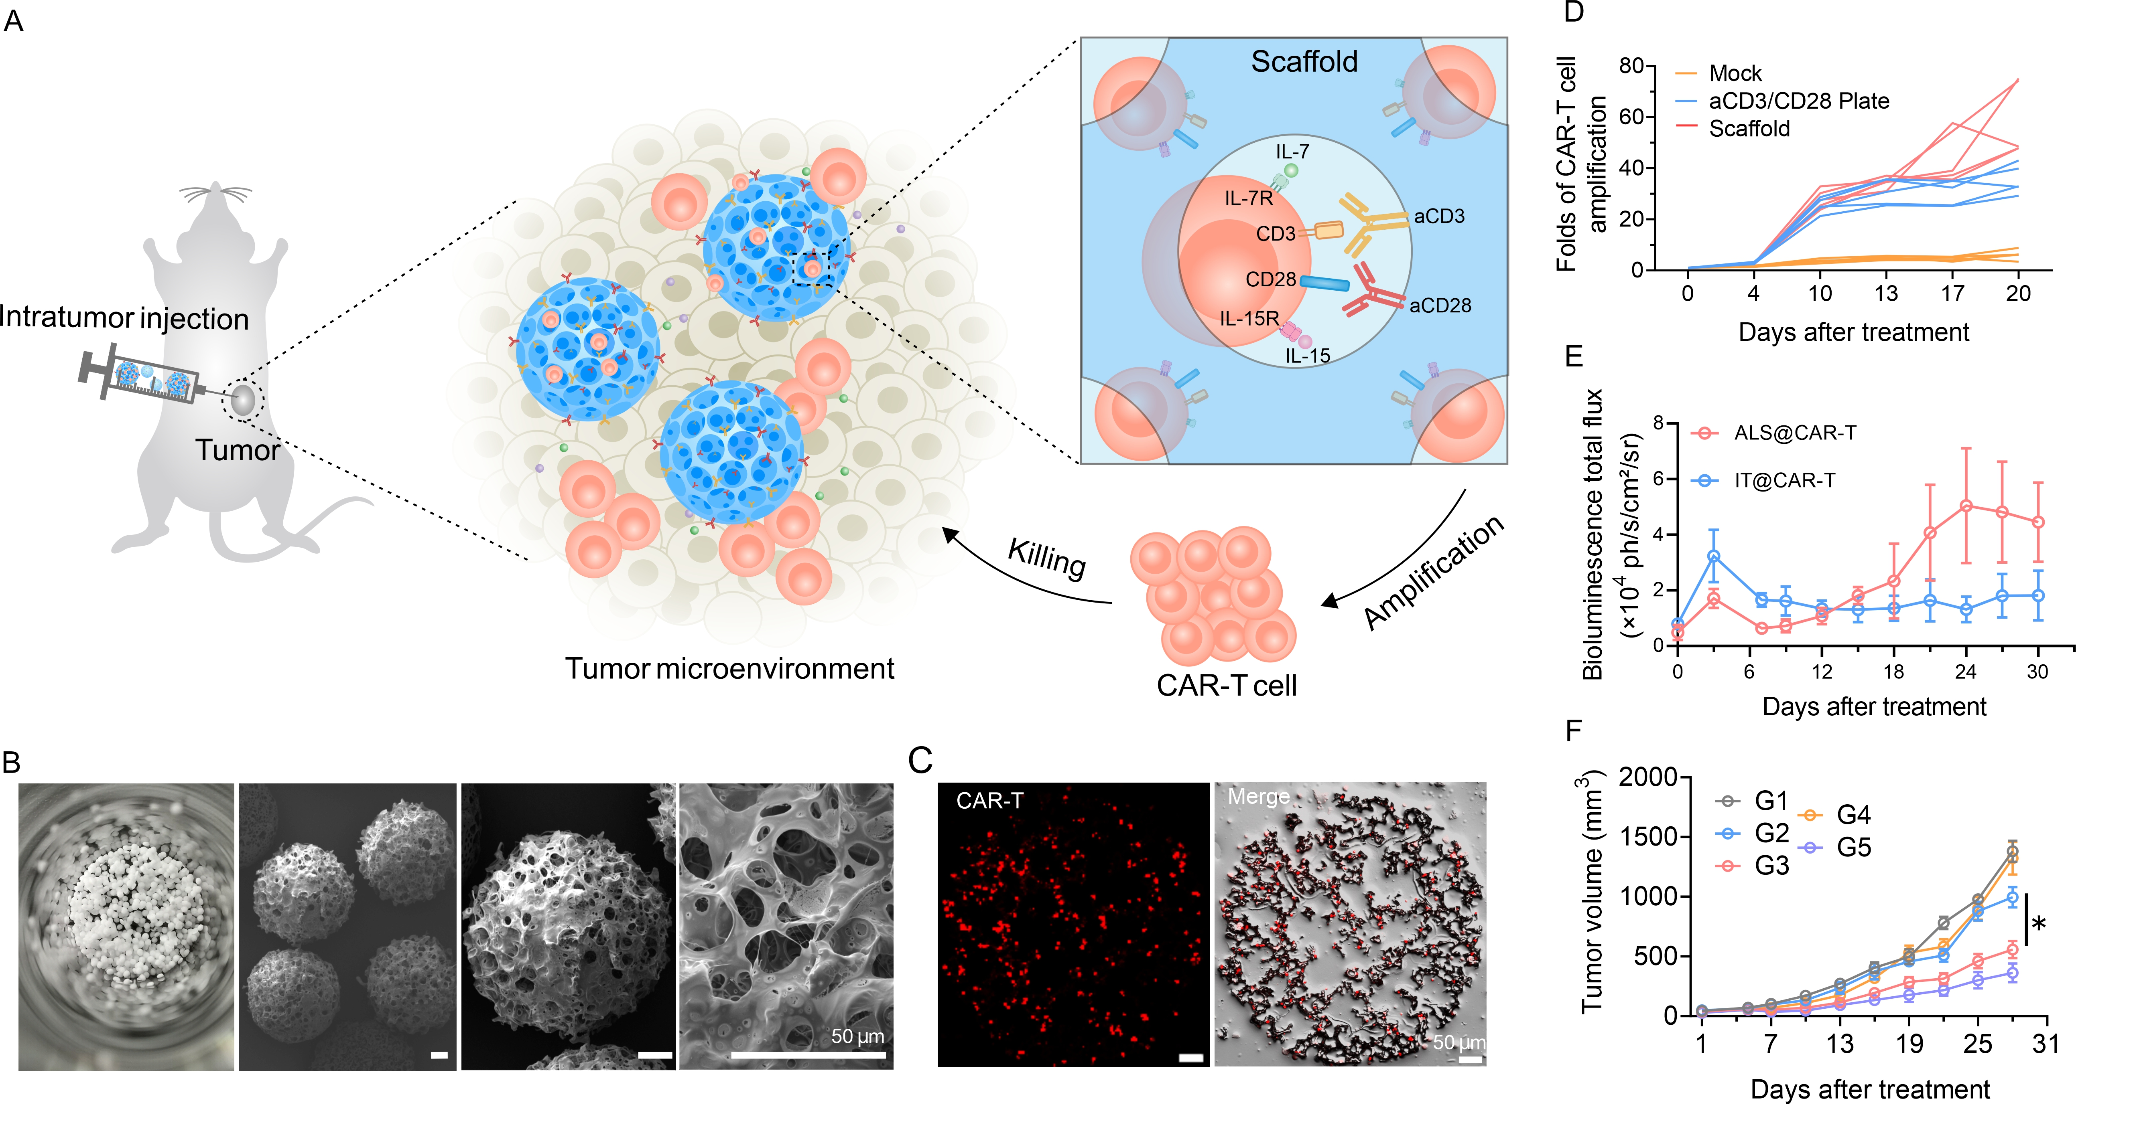

**Figure 1.** The artificial lymph node-like scaffold (ALS) promotes CAR-T cell expansion and activity. (A) Schematic of ALS. (B) Representative scanning electron microscope images of ALS. (C) Confocal images of CAR-T cells within ALS. (D-E) The expansion curve of CAR-T cells *in vitro* (D)and *in vivo* (E). (F) *In vivo* anti-solid tumor activity.

**Conclusion/Discussion.** The lymph node-biomimetic scaffold gathers the function of loading, delivery, activation, and expansion for CAR-T cells and significantly enhances the solid tumor treatment efficacy of CAR-T cell therapy in a xenograft tumor mouse model. Future work will explore clinical translation and combinatorial therapies.

**References:** (1) June CH. et al (2018) Science 359: 1361-5

**Acknowledgements:** This work was supported by the National Natural Science Foundation of China (Grant No. 52233013, 52173142) and the National Key R&D Program of China (Grant No. 2021YFA0909900).