Contributions of the natural health products industry to pharmacovigilance, a scoping review.
Xin Yi Lim¹, Sanya Ram¹, Shane Scahill¹, Joanne Barnes¹. School of Pharmacy, University of Auckland¹, Grafton, AKL, New Zealand.

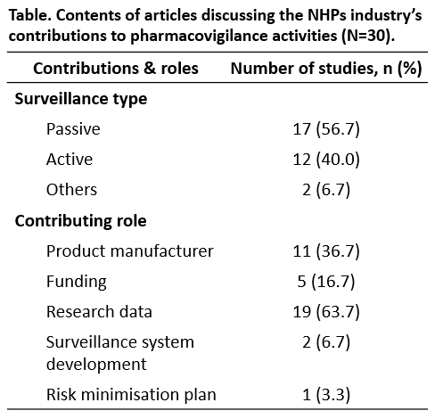
Introduction. Industry parties are key players in pharmacovigilance, including natural health products (NHPs). However, in contrast to their counterparts in the pharmaceutical industry, the roles of the NHPs industry in pharmacovigilance and their contributions, particularly where not mandated, are not well explored.
Aims. To undertake a scoping review to collate and map global literature on the contributions of the NHPs industry towards pharmacovigiilance for NHPs.
Methods. We searched seven international electronic journal databases (MEDLINE, EMBASE, CINAHL, AMED, IPA, PsycINFO, and Scopus) and selected local grey literature in New Zealand, up to March 2023, for articles reporting the contributions of the NHPs industry towards pharmacovigilance for NHPs, using pre-determined combined keyword and MeSH search strategies.
Results. Of the 2021 published articles identified, 30 articles that described both active and passive contributions of the NHPs industry to surveillance activities were included. In community-based surveillance, the NHPs industry mainly contributed through collection of spontaneous reports. Some companies undertook active surveillance for their products, though primarily limited to clinical settings. Of 59 grey literature articles found on the New Zealand Medsafe website, 18 described industry engagement, mostly involving the regulator’s requests for product recalls due to adulterated products.
Discussion. The NHPs industry predominantly contributes to pharmacovigilance through passive surveillance. Active surveillance initiatives involving the NHPs industry were conducted in non-community settings, overlooking most NHPs use. Future studies could explore the potential of the NHPs industry in assuming a more prominent role in voluntarily undertaking pharmacovigilance for NHPs, particularly through proactive surveillance methods within community settings.

