Extracellular vesicles promote gliosis modulation and reprogramming in X-linked juvenile retinoschisis
Yu-Hua Wang¹, Chih-Ying Chen², Shi-Hua Chiou^{1,2}. ¹Dept. of Pharmacology, National Yang Ming Chiao Tung University, Taipei, Taiwan. ²Dept. of Medical Research, Taipei Veterans General Hospital, Taipei, Taiwan

Introduction.X-linked juvenile retinoschisis (XLRS), caused by RS1 mutations, results in retinal lamination defects and early-onset vision loss. While gene therapies have shown promise, durable outcomes remain limited. Müller glia (MG) undergo reactive gliosis and inhibit regeneration. Extracellular vesicles (EVs) derived from MG may deliver regulatory microRNAs (miRNAs) that modulate gliosis and promote glial dedifferentiation.
Aims.This study investigates the therapeutic potential of EVs from human iPSC-derived retinal organoids (wtRO-EVs) and organoid-derived MG (wtRO-MG-EVs) in modulating gliosis and cellular reprogramming in an XLRS retinal organoid model.
Methods.Peripheral blood mononuclear cells (PBMCs) from a healthy volunteer and an XLRS patient (p.R209C) were reprogrammed into iPSCs and differentiated into retinal organoids. MG cells were expanded from day-120 organoids. EVs were isolated by differential ultracentrifugation and characterized following MISEV2023. Small RNA sequencing and qPCR will profile miRNAs such as miR-1246, miR-21-5p, and miR-92a-3p. Functional assays are underway to assess changes in GFAP, Sox9, Pax6 and Sox2 expression via qPCR and immunofluorescence.
Results.Retinal organoids derived from the RS1 mutant line exhibited neurosensory retina splitting and irregular RS1 expression. GFAP upregulation confirmed the presence of reactive gliosis in XLRS models.
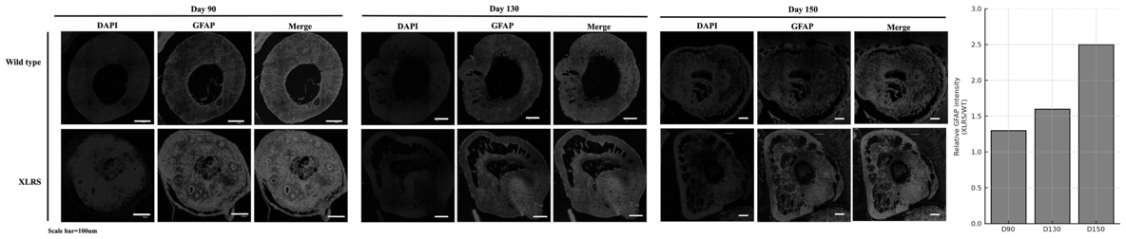
Discussion.This ongoing study aims to explore whether MG-derived EVs can modulate gliosis and promote dedifferentiation in retinal organoids. Preliminary data supports the potential of EV-based, cell-free therapeutics for XLRS. Future directions include ATAC-seq to assess chromatin remodeling in MG following EV treatment.

