The effects of different resistance mechanisms on Pseudomonas aeruginosa response to meropenem
Dominika T. Fuhs¹, Sara Cortés-Lara², Jessica R. Tait¹, Kate E. Rogers¹, Carla López-Causapé², Wee Leng Lee¹, Roger L. Nation¹, Antonio Oliver², Cornelia B. Landersdorfer¹. Monash Institute of Pharmaceutical Sciences, Monash University¹, Parkville, Vic, Australia. Servicio de Microbiología, Hospital Universitario Son Espases-IdISBa², Palma de Mallorca, Spain.

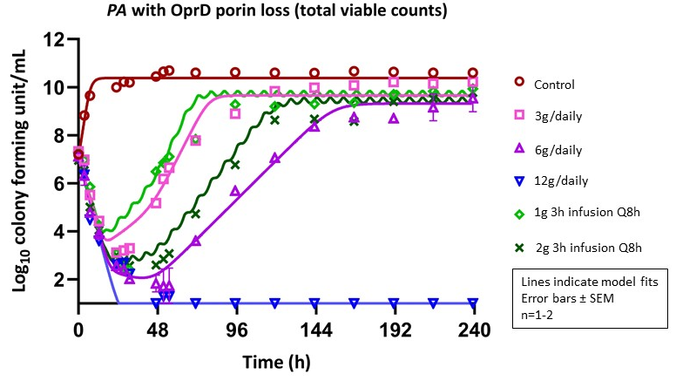
Introduction. Meropenem (MEM) is used against Pseudomonas aeruginosa (PA) infections, but resistance mechanisms reduce its effectiveness. Mechanism-based mathematical models (MBMs) address limitations of PK/PD indices, such as the time free antibiotic concentration exceeds the pathogen’s min. inhibitory conc. (fT_{>MIC}).
Aims. Characterise the effects of different baseline resistance mechanisms on bacterial killing and resistance emergence; evaluate whether fT_{>MIC} can predict these effects; develop a novel MBM.
Methods. We conducted 10-day hollow-fibre infection model (HFIM) studies using seven isogenic PA strains with OprD porin channel loss, MexAB-OprM efflux pump over-expression, AmpC β-lactamase over-expression, and the combinations thereof. The HFIM simulated MEM PK for critically-ill patients with normal renal function (t_{1/2,MEM}=1.5h). All viable counts on drug-free, 3×MIC and 5×MIC MEM-containing agar across all strains, five clinically relevant regimens and control (n=90 profiles) were modelled simultaneously.
Results. fT_{>MIC} could not explain the differences in bacterial response between strains. For example, regimens achieving ≥98% fT_{>1xMIC} suppressed regrowth and resistance of one strain, while even 100% fT_{>5xMIC} failed to achieve this against two other strains, despite all three of these having the same MIC. In contrast, the MBM well characterised all bacterial outcomes of all seven strains with the same model structure and without estimating strain-specific drug effect parameters (observed vs individual-fitted r²=0.98, observed vs population-fitted r²=0.96, Fig. shows one strain).
Discussion. The resistance mechanisms were described by their effects on the estimated MEM concentration in the periplasmic space, which led to different bacterial outcomes, even for strains with the same MIC. The developed MBM is the first model to directly translate all major mechanisms of MEM resistance in PA and their complex interplay.

