Drug discovery trends – Which compounds, targets and diseases are gaining interest?
Javier Sánchez Lorente¹, Aleksandr V Sokolov ², Helgi B Schiöth^{2,3}, David E Gloriam¹. ¹Department of Drug Design and Pharmacology, University of Copenhagen, Copenhagen, Denmark. ²Department of Surgical Sciences, Functional Pharmacology and Neuroscience, University of Uppsala, Uppsala, Sweden.

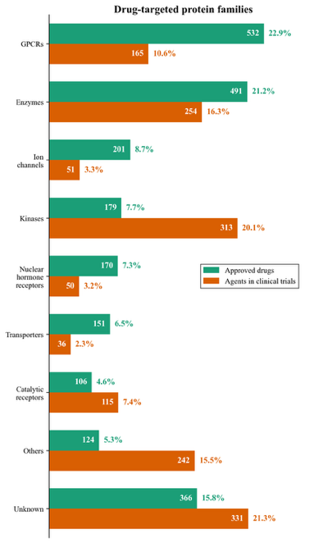
Introduction. Drug discovery is advancing rapidly with swift shifts across compounds, targets and diseases. Over a thousand compounds and a hundred targets are emerging for the first time in clinical trials. Furthermore, around half of the nearly two thousand approved drugs are being tested again, for additional diseases.
Aims. Reveal insights on current trends in current clinical trials across all compounds, targets, and diseases (Lorente JS et al, manuscript).
Methods. We leverage our pipeline from (Lorente et al., 2025) to integrate data from OpenTargets, Therapeutic Target Database, DrugBank and ClinicalTrials.gov. We also develop AI-based searches and manually annotate company pipelines and press releases to complete data.
Results. Our analysis gains insights into the following major questions: Which are the most prominent drug targets and which protein families are new or increasing in clinical trials? What is the distribution of approved drugs across disease areas, and which disease areas are gaining in clinical trials? What are the trends in molecule type, pharmacological mechanism-of-action and specificity of new agents in trial compared to approved drugs?
Discussion. This study presents insights on current clinical trends and an actionable foundation for researchers, biotech companies, and pharmaceutical developers, seeking to reduce the risk and cost of drug discovery.

Lorente JS et al, manuscript
Lorente JS et al (2025) Nat Rev Drug Discov, 24:458-479

