**Design of Experiment-Based Development of Spray-Dried Sumatriptan Particles for Enhanced Nose-to-Brain Delivery**

**Jieun Jeong1**, Heejun Park1.

Pharmaceutical Research Laboratory, Department of Pharmacy, Duksung Women’s University, Seoul, South Korea1.

**Background and aims.** Sumatriptan, a therapeutic agent for migraine, is classified as a Biopharmaceutics Classification System Class III drug, characterized by limited permeability and therapeutic efficacy. In this study, various permeation enhancers were screened to improve mucosal permeability, and porous particles were designed to enable direct nose-to-brain delivery by bypassing the blood–brain barrier (BBB). To enhance intranasal delivery efficiency, inhalable porous particles were prepared via spray drying (SD), using mannitol as a carrier and ammonium carbonate as a porogen. The Design of Experiments (DoE) approach with a Box–Behnken Design (BBD) was applied for process variable screening.

**Methods.** An aqueous solution containing 80% mannitol, ammonium carbonate, and 20% sumatriptan was prepared and spray-dried to obtain porous particles. The process was conducted under co-current flow conditions with a feed rate of 3 mL/min, atomizing pressure of 0.2 bar, inlet temperature of 90–100 °C, outlet temperature of 50–55 °C, and heated air flow of 0.4 m³/min.

**Results.** Among the permeation enhancers tested, AI and AL significantly improved permeability in SNF PAMPA, RPMI 2650 cell assays, and ex vivo porcine nasal mucosa. BBD analysis identified drug concentration and ethanol ratio as key factors affecting yield, particle size distribution, and surface properties of sumatriptan-loaded porous mannitol particles. Notably, a rare polymorphic transformation of mannitol from β-form to δ-form was observed during SD. DSC analysis showed a distinct sumatriptan peak at 140 °C, with no detectable polymorphism in XRD and FTIR analyses.

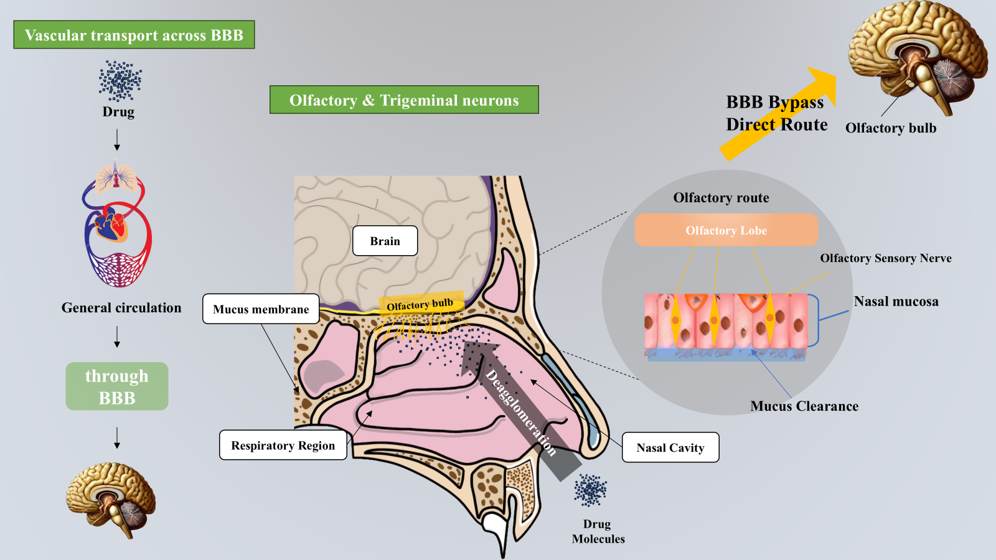 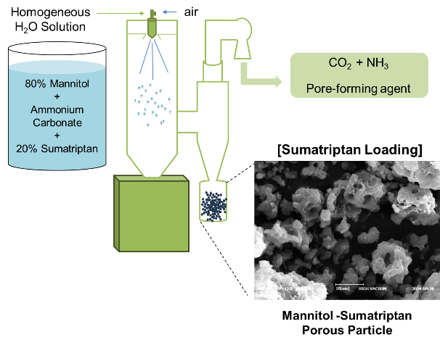

**Figure 1.** Nasal Drug Delivery for Enhanced Brain Targeting. **Figure 2.** Preparation of formulations.

**Conclusion/Discussion.** BBD and solid-state analyses revealed that sumatriptan interacts with porous mannitol, inducing polymorphic transitions during SD. Permeability screening based on the DoE approach identified effective strategies to enhance drug absorption. These findings support the future development of optimized porous mannitol particles co-loaded with permeability enhancers and sumatriptan for improved drug delivery.

**Acknowledgements** This work was supported by the National Research Foundation of Korea (NRF) grant funded by the Korea government (MSIT) (No.2022R1C1C1010130). This work was supported by the Korea Basic Science Institute (National Research Facilities and Equipment Center) grant funded by the Korea government (MSIT) (No.RS-2024-00404864). This research was supported by the Technol-ogy Innovation Program (RS-2025-11572968), funded by the Ministry of Trade, Industry and Energy (MOTIE, Korea).

**References:**

(1) Masjedi M. et al (2020) J Pharm Pharmacol 72:1341–1351.

(2) Yang Y. et al (2022) Crystals 12:1080.

(3) Li X. et al (2014) J Pharm Sci 103:2937–2949.