**Determining the Optimal Dosing of Methyldopa in Pregnancy-Induced Hypertension Using PBPK-PK/PD Modeling**

**Xinyang Liu¹,** Wei Wang¹, Jinying Zhu¹, Defang Ouyang¹.

Institute of Chinese Medical Sciences (ICMS) 1, University of Macau, Macau, China

**Background and aims.** Pregnancy-induced hypertension is a significant risk factor for adverse maternal and fetal outcomes, with methyldopa being a commonly prescribed antihypertensive for its safety profile (1). However, the physiological changes during pregnancy may alter methyldopa's pharmacokinetics and pharmacodynamics, complicating the establishment of optimal dosing regimens. This study aims to develop and validate a pregnancy-specific PBPK-PK/PD model for methyldopa to optimize dosing strategies and support individualized treatment plans.

**Methods.** The PBPK-PK/PD model for methyldopa was developed using PK-Sim, MoBi, and MATLAB software, incorporating pregnancy-specific physiological parameters from the literature. The development process involved: first, constructing and validating a PBPK model for non-pregnant individuals based on intravenous and oral administration, including renal clearance, serum clearance, and enzyme clearance; second, extending the model to a pregnant PBPK model and validating it for oral administration; third, constructing a PK/PD model using the maximum effect model; and then, integrating the PBPK and PK/PD models to form a unified PBPK-PK/PD model. This model was then used to simulate mean arterial pressure (MAP) responses across different stages of pregnancy. Finally, the optimal dosing regimen was calculated.

**Results.** The model verification results show a good fit, indicating that the parameters are appropriate. The pregnancy model indicated no significant change in PST activity during pregnancy. The PBPK-PK/PD simulations across different stages of pregnancy show fluctuations in both PK and PD (see Figure 1). Ultimately, the results indicate that 500 mg is the optimal dosing regimen for patients with MAP ≤ 130 mmHg. For MAP > 130 mmHg, additional antihypertensive medications are recommended (see Table 1).

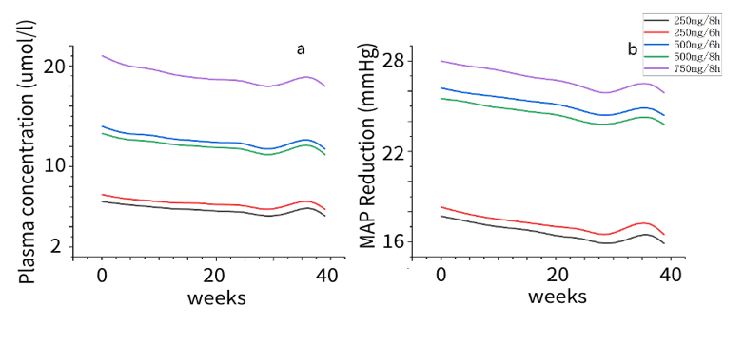

|  |  |  |
| --- | --- | --- |
| **Dosing Regimen**  **(mg)** | **MAP Reduction**  **(mmHg)** | **For**  **MAP**  **(mmHg)** |
| **250** | **17** | **105-122** |
| **500** | **25** | **122-130** |
| **750** | **27** | **130-132** |

**Figure 1.** PBPK-PK/PD predictions for pregnant women. a. PBPK predictions: The y-axis represents the peak steady-state plasma concentration after multiple doses. b. PBPK-PK/PD predictions: The y-axis represents the steady-state MAP reduction effect after multiple doses. **Table 1.** Precision dosing calculation.

**Conclusion/Discussion.** The PBPK-PK/PD model developed in this study provides a valuable tool for optimizing methyldopa therapy, supporting personalized treatment strategies, and improving blood pressure management and maternal and fetal health outcomes in pregnancy-induced hypertension.

**References:**

(1) Khedagi AM, Bello NA. Hypertensive Disorders of Pregnancy. Cardiology Clinics. 39(1), 77–90 (2021).