**Targeted MYC Inhibition in HER2+ Breast Cancer: Exploring the Potential of mAb Conjugated siRNA Loaded Chitosan Nanoparticles**

**Angel Treasa Alex1**, Tamanna Tanwisa1, Alan Raj

1Department of Pharmaceutical Biotechnology, Manipal College of Pharmaceutical Sciences, Manipal Academy of Higher Education, Manipal, Udupi, Karnataka, India

**Background and aims.** MYC is a proto-oncogene highly expressed in breast cancer. Its intrinsically disordered structure and absence of a defined binding pocket make small molecule inhibitor development difficult[1]. Targeting MYC mRNA with siRNA is an effective strategy for inhibiting such disordered proteins. siRNA faces delivery and serum degradation challenges[2]. Chitosan nanoparticles are effective genetic material carriers, and targeting can be enhanced by functionalizing them with ligands like Trastuzumab. The aim of this study is to design Myc specific siRNA and develop Trastuzumab (TR) conjugated chitosan nanoparticle loaded with siRNA to manage HER2+ breast cancer.

**Methods.** siRNA (25 bp) was designed and synthesized. PEGylated chitosan nanoparticles were optimized by DoE and prepared using ionic gelation, varying chitosan/TPP concentrations and sonication amplitude, with particle size, PDI, and zeta potential as outputs. Nanoparticles were conjugated with trastuzumab and characterized. Anticancer effects were evaluated by cytotoxicity, scratch assay, cellular uptake, and RT-PCR in SK-BR-3 cells.

**Results.** Myc specific siRNA was designed, screened (GC content, positions of bases, presence of A/U residue) synthesized and was used for the nanoparticle preparation. Optimized nanoparticles had a size of 126.0±2.5 nm, PDI 0.237±0.061, zeta potential 25.9±1.98 mV, and 40.5±2.22% entrapment efficiency (confirmed by gel retardation). TEM showed spherical shape; SDS-PAGE confirmed trastuzumab conjugation. siRNA release was higher at pH 6.4 than 7.4. TR-conjugated nanoparticles showed superior cytotoxicity and anticancer activity in scratch assays and effectively knocked down MYC gene in SK-BR-3 cells (RT-PCR).

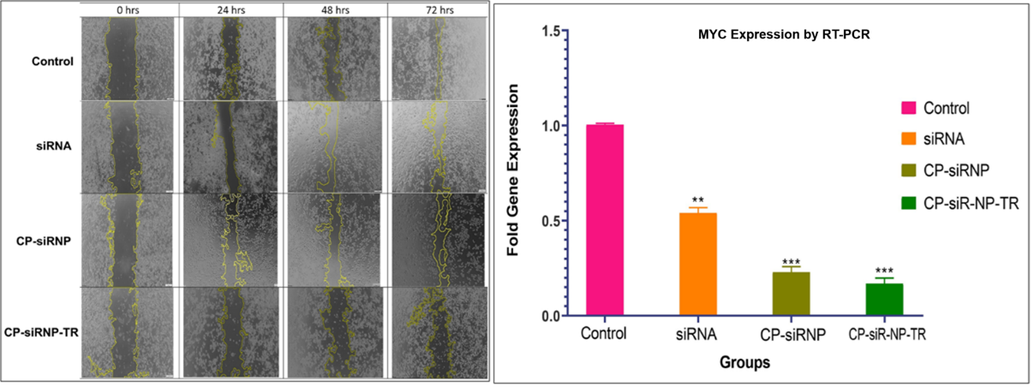

**Figure 1.** Scratch wound and RT-PCR results of siRNA and developed nanoparticles on SK-BR-3 cells

**Conclusion/Discussion.** The designed siRNA shows good MYC inhibition. The siRNA loaded PEGylated chitosan NP conjugated with Trastuzumab were successfully developed for targeted MYC silencing in Her2+ breast cancer, and the nanoparticles show better MYC inhibition cytotoxicity compared to plain siRNA demonstrating the therapeutic advantage of the developed targeted formulation.

**Acknowledgements**

We sincerely thank Manipal Academy of Higher Education (MAHE) and MCOPS, MAHE for providing the infrastructure and facilities for this research. We thank the Indian Council of Medical Research (ICMR) for financial support (5/13/37/2020/NCD III).

**References**

[1] Llombart V, Mansour MR. Therapeutic targeting of “undruggable” MYC. *EBioMedicine* 2021;**75**:103756.

[2] Ali Zaidi SS, Fatima F, Ali Zaidi SA, Zhou D, Deng W, Liu S. Engineering siRNA therapeutics: challenges and strategies. *J Nanobiotechnology* 2023;**21**(1):381.