**High Performance Thin-Layer Chromatography (HPTLC) As A Convenient Analytical Tool For The Analysis of Active Pharmaceutical Ingredients In Ointments**

**K M Yasif K Sikdar1**, Md K Islam1, Lee Yong Lim1,2, Cornelia Locher1,2.

1Division of Pharmacy and Centre for Optimisation of Medicines, The University of Western Australia, Crawley, WA 6009, Australia;

2Institute for Paediatric Perioperative Excellence, The University of Western Australia, Crawley, WA 6009, Australia.

**Background and aims.** High-performance thin-layer chromatography (HPTLC) is a widely utilised technique for the qualitative and quantitative analysis of natural products. It is also growing in popularity in the field of pharmaceutical analysis and quality control as it allows the parallel analysis of a large number of samples using minimal solvent input, often even without the need for pre-analysis extraction. This study aims to demonstrate the convenience of HPTLC for analysing targeted molecules in pharmaceutical ointments, by developing an analysis protocol without excipient interference nor the necessity of a prior drug extraction step.

**Methods.** HPTLC methods were developed and validated according to International Council for Harmonisation (ICH) guidelines for analysing nitrofurazone and tacrolimus ointments. Both ointments were directly dissolved for analysis in chloroform-acetone (9:1, *v/v*) and cyclohexane‒chloroform (2:1, *v/v*) respectively without any pre-extraction step. Optimised solvent systems were also used in the chromatographic development of the drugs, which were detected at 370 and 366 nm respectively.

**Results.** In their respective mobile phases, nitrofurazone can be detected at RF 0.18 and tacrolimus at RF 0.20 without any interference of other ointment components (Figure 1a, Figure 1b). Precision, accuracy, robustness and repeatability of the developed methods were all within acceptable limits as per ICH guidelines with a detection and quantification limit were 10.39 and 31.49 ng/band for nitrofurazone as well as 5.68 and 17.20 ng/band for tacrolimus respective.

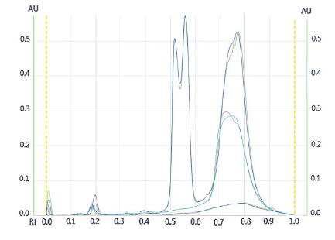

(a) (b)

**Figure 1.** (a) HPTLC chromatograms: Track 1, 2: Nitrofurazone; Track 3,4: Blank simple ointment; Track 5,6: Nitrofurazone ointment; (b) HPTLC chromatograms for tacrolimus standard, tacrolimus simple ointment and tacrolimus firm ointment

**Conclusion/Discussion.** This study demonstrates that the developed and validated HPTLC methods can accurately quantify drug content in the ointments without excipient interference or the need for prior drug extraction. These findings highlight the convenience of HPTLC analysis in the quality control of pharmaceutical ointments.

**References:** This research was conducted during the author receipt of an International Fee Scholarship and a University Postgraduate Award from the University of Western Australia.

(1) Islam, M.K. et al (2020) JPC 33: 489-499

(2) Islam, M.K. et al (2020) Molecules 25: 5289

(3) Islam, M.K. et al (2021) JPC 34:189-195