Utilizing Nanotechnology for the Delivery of Targeted Fertility Control Agents to Pest Wildlife
Arlene McDowell¹, Rasika Eggers^{1,2}, Soheil Mehrdadi¹, Thomas Rades², Regan J. Anderson³, Greg M. Anderson⁴.
School of Pharmacy, University of Otago¹, Dunedin, New Zealand;
Department of Pharmacy, University of Copenhagen², Copenhagen, Denmark;
Ferrier Research Institute, Victoria University, Wellington, New Zealand;
Department of Anatomy, University of Otago⁴, Dunedin, New Zealand.

Background and aims. Wildlife pests are invasive species that threaten biodiversity and transmit zoonotic disease – integral aspects of One Health. New technologies are needed urgently to effectively control pest wildlife (1). The brushtail possum is the most significant vertebrate pest in New Zealand and disrupting fertility is a humane and effective method of population reduction. We have designed new peptide constructs that can induce permanent sterilization and importantly, only mammals are affected meaning that the endangered birdlife in New Zealand remain fertile. Drug delivery to free ranging wildlife remains a major hurdle in the deployment of new chemical control methods. The utility of nanomedicines in human medicine has been demonstrated, however the application of nanoformulations in wildlife is untested.

Our aim is to investigate nanotechnology for the delivery of the targeted contraceptive agents for brushtail possums in Aotearoa New Zealand.

Methods. Neuropeptide analogues that target neurones that regulate reproduction in the brain have been conjugated to a cytotoxin using solid-phase synthesis and the modulation to the female reproductive cycle patterns in mice is investigated. Microfluidics combined with a Design of Experiments approach was used to synthesize poly-lactic-co-glycolic acid (PLGA) nanoparticles containing contraceptive agents.

Results. We have synthesized uniform PLGA nanoparticles with an average size of 218 nm (Figure 1) and a zeta potential of -32 mV. Entrapment efficiency of peptide was 22%.

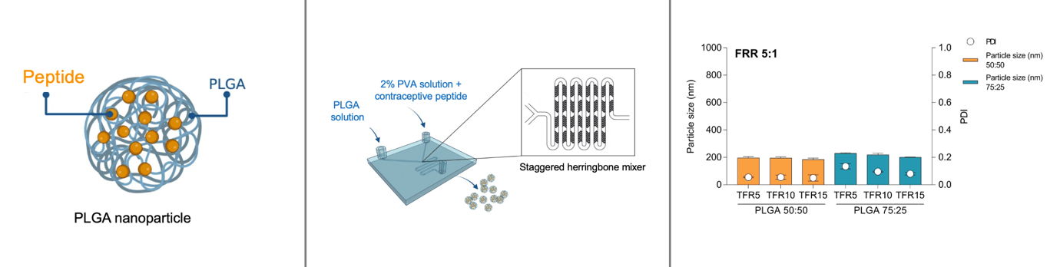

Figure 1. Production and optimisation on nanoformulations containing contraceptive peptides.

In preliminary studies, peripheral and central administration of 10 μM of targeted neuropeptide-cytotoxin analogues have shown a disruption to reproduction cycles and fertility in a mammalian model.

Conclusion. We have demonstrated that contraceptive peptides can be efficiently entrapped in PLGA nanoparticles using microfluidics. These cell-specific cytotoxins represent a novel approach to controlling mammalian fertility in vivo.

Acknowledgments. We thank MBIE Smart Ideas and Predator Free 2050 for funding.

References:
- McDowell, A. (2022). International Journal of Pharmaceutics 628: 122284

