**Injectable Thermosensitive Hydrogel for Tunable Contraception: Controlled Delivery of Etonogestrel**

**Zhengping Ge1**, Chenxi Yang2, Yiwei Wang1,3,4.

School of Pharmacy, Nanjing University of Chinese Medicine1, Nanjing, Jiangsu Qixia, PR China;

School of Medical, Nanjing University of Chinese Medicine2, Nanjing, Jiangsu Qixia, PR China;

Jiangsu Collaborative Innovation Center of Chinese Medicine Resource Industrialization Process, Nanjing University of Chinese Medicine3, Nanjing, Jiangsu Qixia, PR China;

ANZAC Research Institute, Concord Hospital, The University of Sydney4, NSW Concord West, Australia.

**Background and aims.** Long-acting contraception hasbecome a major research focus in reproductive health due to the significant gap between high market demand and limited product availability. This study developed an injectable thermosensitive hydrogel system – poly (N-isopropylacrylamide-co-hydroxyethylacrylamide-co-etonogestrel) (PNPHO-ENG) designed to achieve prolonged and tunable contraceptive effects by precisely modulating hydrogel degradation properties.

**Methods.** Tuable-acting injectable hydrogels were synthesized via free-radical polymerization of poly(N-isopropylacrylamide-co-hydroxyethylacrylamide-co-etonogestrel) (PNPHO) and etonogestrel (ENG). FTIR and ¹H-NMR confirmed the molecular structure. Thermosensitive sustained released behaviour was demonstrated using the inversion method and LC-MS analysis. Contraceptive efficacy was also assessed through animal mating experiments as well as histological analysis.

**Results.**FTIR and ¹H-NMR confirmed successful grafting of PNPHO and ENG, achieving a drug loading of approximately 95.3%. Both In vitro and in vivo release studies showed sustained drug delivery, maintaining effective plasma concentrations (Figure 2). Mating experiments demonstrated that a 1 mL/kg dose of PE gel (140 mg/mL) provided 20 days contraception without impacting fertility or offspring health.

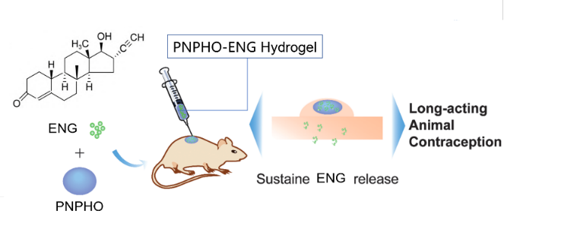

**Figure 1.** Schematic illustration of ENG-loaded injectable hydrogel formulation.

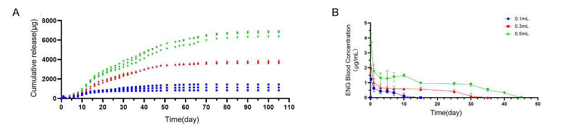

**Figure 2.** PNPHO-ENG release profiles (n=3). (A) Cumulative in vitro release; (B) Plasma concentration kinetics.

**Conclusion/Discussion.**

The PNPHO-ENG hydrogel enables sustained and stable progestin release, with an adjustable injection dosage allowing flexible control over contraceptive duration. This system presents a safe, effective, and promising approach for long-acting contraception.

**References:**

(1) Sreekanth Pentlavalli et al (2025) Journal of Controlled Release 379:30–44

(2) Xi Chen et al (2017) J. Biomed. Nanotechnol Vol. 13, No. 11

(3) Jingjunjiao Long(2019) ACS Appl. Bio Mater. 2, 2766−277