From bitter to better medicines: a preclinical tool to predicts bitterness and level of sweetness to mask it

Robert Ives¹, Sejal R. Ranmal^{1,2}, Catherine Tuleu^{1,2}
senCeuTics Ltd¹, London, United Kingdom;
UCL School of Pharmacy², London, United Kingdom.

Background and Aims Poor taste, particularly bitterness, is a major barrier to medication adherence in children [1]. The rat Brief Access Taste Aversion (BATA) (Fig 1) assay is a clinically translatable model for predicting bitterness [2, 3]. While rats are good predictors of the bitter-masking potential of natural sugars like sucrose, they are less reliable for non-nutritive sweeteners. Since it is the intensity of sweetness, rather than the sweetener itself, that primarily masks bitterness, this study used the BATA model to: (1) assess the aversiveness of a known bitter compound, (2) evaluate the effectiveness of sucrose in mitigating this aversiveness, and (3) estimate equi-sweet concentrations of alternative sweeteners. | 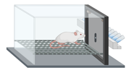  Figure 1. Rat in a “lickometer” which records the number of “licks” that the rat makes to different concentrations of compound tested presented randomly in several sipper tube between short water rinse [2]

Methods In Phase 1, a bitter compound [3] was tested at various concentrations (~0.5 log intervals) in 10 rats using the MED-DAV-160M Davis Rig lickometer. Each rat participated in two 30-minute sessions over two days. A concentration-response curve was generated. In Phase 2, one week later, the same rats were presented with a fixed concentration of the compound (IC75 from Phase 1) combined with increasing concentrations of sucrose. Data were analysed using non-parametric statistics. All procedures complied with the Animals (Scientific Procedures) Act 1986.

Results. Phase 1 (Fig 2) confirmed the compound’s aversiveness, with 0.1 mMol producing ~50% of the maximum lick rate (IC50). In Phase 2 (Fig 3), 10% sucrose increased licking to ~50%, while 30% sucrose achieved ~80%, a level likely more acceptable for children. This intensity is not achievable with individual artificial sweeteners but might be with blends. Sucrose equivalent sweetness levels for artificial sweeteners can be calculated based on their sweetness intensity (Fig 4).
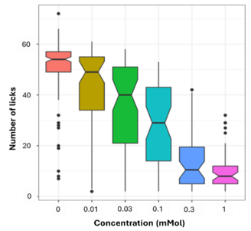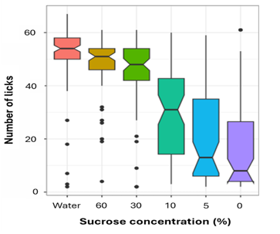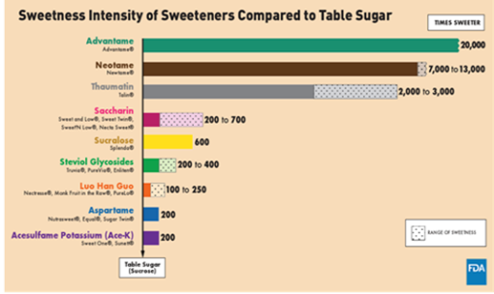
Figure 2. Concentration- Figure 3. Aversive taste Figure 4. Sweetness intensity of
response for bitter compound mitigation with sucrose alternative sweeteners relative to sucrose [4]

Conclusion. The BATA model effectively predicts bitterness and can assess whether sweetness effectively mitigates aversive taste, and the level required to achieve this. It supports formulation (taste masking) decisions, reduces reliance on human sensory trials, and can accelerate the development of palatable paediatric medicines.
References:
(1) Ranmal SR, Walsh J, Tuleu C. Front Drug Deliv. 2025; 5:1553286. http://doi.org/10.3389/fddev.2025.1553286
(2) Soto J, et al. Eur J Pharm Biopharm. 2018; 133:77-84. https://doi.org/10.1016/j.ejpb.2018.09.027
(3) Clapham D, et al. Pharmaceutics. 2023; 15:2319. https://doi.org/10.3390/pharmaceutics15092319
(4) U.S. Food and Drug Administration. Sweetness Intensity of Sweeteners Compared to Table Sugar. Accessed 18/06/25.

