**Trends in hospital admissions from adverse drug reactions among older Australians**

Azizah Vonna1,2, Mohammed S. Salahudeen1 & Gregory M. Peterson 1. School of Pharmacy and Pharmacology, Univ of Tasmania 1, Hobart, TAS, Australia; Department of Pharmacy, Univ Syiah Kuala 2, Banda Aceh, ACH, Indonesia.

Introduction. While there was considerable research into adverse drug reaction (ADR)-related hospital admissions among older adults in the late 1990s and early 2000s, such studies have become less common in recent years (Lim et al, 2022). It is therefore difficult to know whether the occurrence of these admissions has changed over time.

Aims. To investigate trends in ADR-related admissions and associated risk factors among older Australian adults.

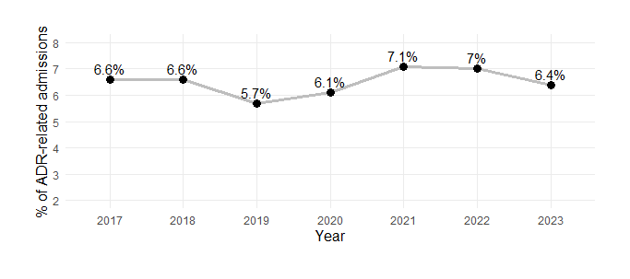Methods. Using data from the Australian National Minimum Data Set (NMDS), we identified older adults (aged ≥65 years) admitted to Tasmanian public hospitals from 2017 to 2023 due to ADRs (using the International Statistical Classification of Diseases and Related Health Problems, Tenth Revision, Australian Modification (ICD-10-AM)). Trends were analysed using a trend analysis and risk factors were assessed using a regression model.

Results. A total of 28,293 out of 444,447 admissions (6.5%) were coded as ADR-related, with annual percentages relatively constant during the observation period (p≥0.05). Of all admitted patients, 9,238 (14.3%) experienced at least one ADR-related admission over the study period. Cancer, peptic ulcer disease, and musculoskeletal disease were associated with the highest risk, with adjusted odds ratios of 5.67 (95% CI: 5.32-6.05; p < 0.0001), 3.21 (95% CI: 2.58-4.00; p < 0.0001), and 2.98 (95% CI: 2.82-3.16; p < 0.0001), respectively.

Discussion. The rate of ADR-related hospitalisations remained stable during the observation period, though the overall percentage is notably higher than findings from similar studies using administrative data from the early 2010s (Lim et al., 2022). Despite an increasing focus on medicines safety, these findings suggest that significant improvements in reducing ADR-related admissions have yet to be achieved.

Lim R et al (2022) Drug Saf 45:249–257.