**Electronic and optoelectronic properties of 2D germanene**

*Nana LiuA, Yilian XiA,B, Jincheng ZhuangB, Yi DuA,B*

AInstitute for Superconducting and Electronic Materials, Australian Institute for Innovative Materials, University of Wollongong, Wollongong, Australia; BBUAA-UOW Joint Research Centre and School of Physics, Beihang University, Beijing, China

2D Xenes (known as 2D elemental materials) beyond graphene, such as silicene, germenene, stanene and blue phosphorene, are new allotropes of silicon, germanium, tin and phosphorus, respectively, in a 2D honeycomb or square lattice with Dirac fermion characteristics. Xene family hosts great potential in promissing applications in electronics, photonics, and the other related areas because they not only demonstrates essentially the same electronic properties as graphene, such as linear dispersion of the electron band and high Fermi velocity, but they also possess an energy gap at the Dirac point, stronger spin-orbital coupling (SOC) and inherent compatibility with the current semiconductor industry.

In this talk, I will review our recent work on 2D Xenes family [1-6], especially, 2D germanene. We demonstrate that high-quality 2D layered germanene can be produced by molecular beam epitaxial deposition and also chemical method. The atomic honeycomb structures have been clearly demonstrated by scanning tunneling microscopy (STM). The phonon properties and distinct electron-phonon coupling effects have been revealed by in-situ Raman spectroscopy. Dirac fermion characteristics of germanene were revealed by scanning tunneling spectroscopy (STS) and angle-revolved photoemission spectroscopy (ARPES). We also successfully observe germanene’s quasi-particle behaviour together with demonstration of its excellent optoelectronic properties.

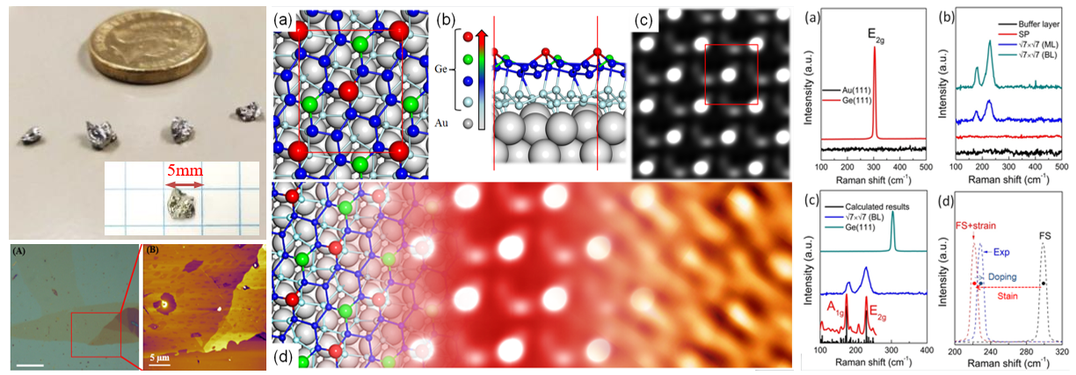

**Figure 1.** Single crystal germanene was synthesized via a chemical route. AFM results verified its 2D layered structure. STM revealed its low-buckled honeycomb lattice in atomic resolution. Raman spectroscopy indicated a large EPC effect of germanene.

**References**

1. Du, Y *et al*., (2016). Quasi-Free-Standing Epitaxial Silicene on Ag(111) by Oxygen Intercalation, Sci. Adv. 2, e1600067.
2. Zhuang, J. C. *et al*., (2017). Cooperative Electron-Phonon Coupling and Buckled Structure in Germanene on Au(111), ACS Nano 11, 3553.
3. Zhuang, J. C. *et al*., (2018). Dirac Signature in Germanene on Semiconducting Substrate, Adv. Sci. 5, 1800207.
4. Zhuang, J. C. *et al*., (2018). Band Gap Modulated by Electronic Superlattice in Blue Phosphorene, ACS Nano 12, 5059.
5. Li, Z. *et al*., (2018). Realization of Flat Band with Possible Nontrivial Topology in Electronic Kagome Lattice, Sci. Adv. 4, eaau4511.
6. Zhang, J. *et al.*, (2019). Reversible Oxidation of Blue Phosphorus Monolayer on Au(111), Nano Lett. 19, 8, 5340.