Swimming in Anxiolytics: Exploring the Behavioural Impact of Pharmaceutical Pollution on Aquatic Wildlife
Jake M Martin, Faculty of Science Engineering and Built Environment, Deakin University, Geelong, VIC, Australia

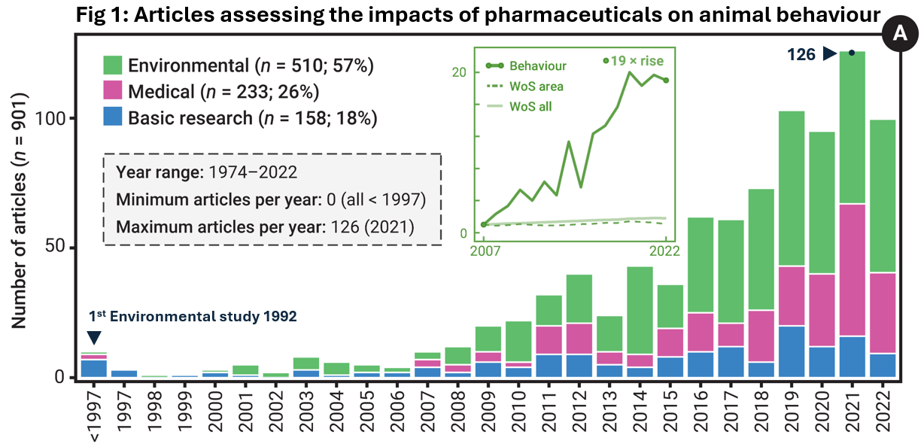
Global pharmaceutical use has surged dramatically over recent decades. While these medications deliver undeniable therapeutic benefits, their extensive use carries unintended environmental consequences. Hundreds of pharmaceuticals infiltrate ecosystems through domestic wastewater, as they are often excreted unmetabolised and resist conventional wastewater treatment processes. Recent environmental surveys reveal an extensive presence of pharmaceuticals in waterways and within the tissues of wildlife. For many such chemicals, we have no data on their environmental impacts; and when we do, they typically take the form of traditional toxicological survival data and fail to capture more nuanced yet ecologically significant sub-lethal effects. As a result, our current knowledge base may underestimate the environmental risks.
This talk will highlight the hidden influence of pharmaceutical pollution on animal behaviour—a largely overlooked driver of ecological change. From antidepressants eroding antipredator responses to anxiolytics disrupting shoaling behaviours and even river-to-sea migration, these behavioural shifts have the potential to cascade into population-level consequences. In addition to highlighting my research in this space, I will also discuss the growing role of animal behaviour as a tool in environmental risk assessment and the rapid expansion of behavioural ecotoxicology as a field (Fig 1).

