Characterising the spatial and temporal interaction of TRPV4 and RhoA signalling
Frankie Zhang¹, Daniel P Poole¹, Shireen Lamande², and Nicholas A. Veldhuis¹
Monash Inst of Pharmaceutical Sciences, Monash Univ¹, Parkville, VIC, Australia and Murdoch Chilren’s Research Inst², Parkville, VIC, Australia
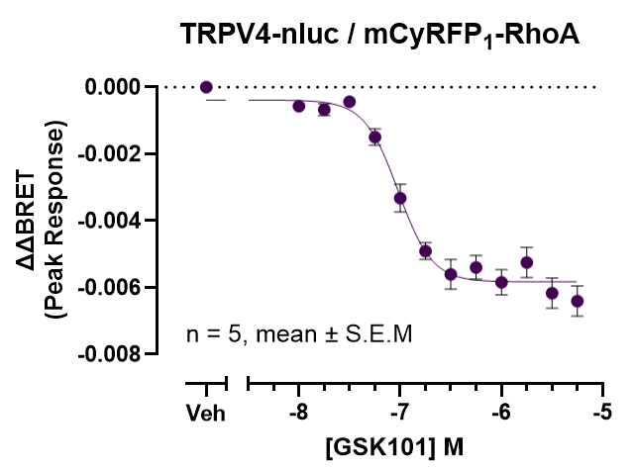
Introduction. Transient Receptor Potential Vanilloid 4 (TRPV4) is a polymodally activated ion channel that integrates physical and chemical signals across tissues. Clinical mutations of TRPV4 result in phenotypically diverse skeletal dysplasias (SD) and neuropathies, yet limited therapeutic options exist. Emerging evidence points to RhoA, a small G-protein, as a candidate regulator of TRPV4 function. Crucially, only neuropathic mutants disrupt the TRPV4-RhoA signalling axis, hinting at disease-specific mechanisms. Despite this, systematic characterisation of the spatial and temporal nature of RhoA binding is scarce.
Aims. To profile the TRPV4-RhoA signalling axis and assess how clinically relevant mutations disrupt this process.
Methods. Bioluminescence resonance energy transfer (BRET)-based biosensors and super-resolution imaging were used to ascertain TRPV4-RhoA localisation. Ligand-induced un-coupling of TRPV4 and RhoA was quantified using BRET.
Results. We observed robust, saturable BRET signals between TRPV4 and RhoA, consistent with specific molecular binding. This was supported by super resolution imaging, where we observed TRPV4-RhoA co-localisation at the cell surface and in intracellular structures. Acute stimulation with TRPV4-specific agonist GSK101 produced a significant, concentration dependent peak reduction in BRET compared to vehicle (-0.006 + 0.0008, n = 5, p<0.001).
Discussion. These findings provide the first direct evidence that TRPV4 and RhoA form a dynamic complex that is disrupted upon channel activation. This further confirms previous findings that RhoA acts as a regulatory partner of TRPV4. Importantly, we highlight potential implications for targeting the TRPV4-RhoA signalling pathway as a therapeutic approach to treat neuropathy-associated TRPV4 mutations.

