Metformin impact on glycemic indices in Prediabetics
Shizma Junejo¹, Pharmacology, Bahria University Health Sciences Campus Karachi ¹, Karachi, Sindh, Pakistan

Introduction. Prediabetes is defined as a state of abnormal glucose homeostasis but not as high as those required for diagnosis of diabetes. Blood glucose levels are elevated above normal level being HbA1c 5.7% to 6.4% and fasting blood glucose 100 mg/dl to 125mg/dl. Mainstay of treatment in prediabetes is lifestyle changes inclusive of diet control and exercise. However if not controlled pharmacotherapy is added. Metformin HCl is a biguanide drug approved by FDA as first line treatment for type 2 diabetes. It is approved for use in pre-diabetes by ADA in 2007.
Aims. To evaluate the clinical efficacy of metformin HCl with lifestyle modifications in pre-diabetics.
Methods.
This study was a randomized controlled clinical trial (RCT) r, pioneer trial globally, registered at clinicaltrials.gov bearing NCT number. Study Setting: Diabetic clinics of National Medical Centre and Bay View Hospital Karachi, Sindh, Pakistan. Study Duration: Individual study duration was 3 months Methodology: Males and females, 17-40 years of age as per ADA 2010 and ISPAD 2018 criteria, were enrolled following ERC and FRC approval. Written informed consent was taken and the subjects along with advice of lifestyle modification, diet control and exercise were given tablet metformin HCl, 500 mg orally BD for 12 weeks. Weight, height, BMI, waist, hip circumference, waist hip ratio), were evaluated at baseline, week 6 and 12. HbA1c and FBG, were evaluated at baseline and week 12.

Results. Majority of participants were in age group 32 to 40 years. The reduction in weight, HBA1c and FBS was highly significant.
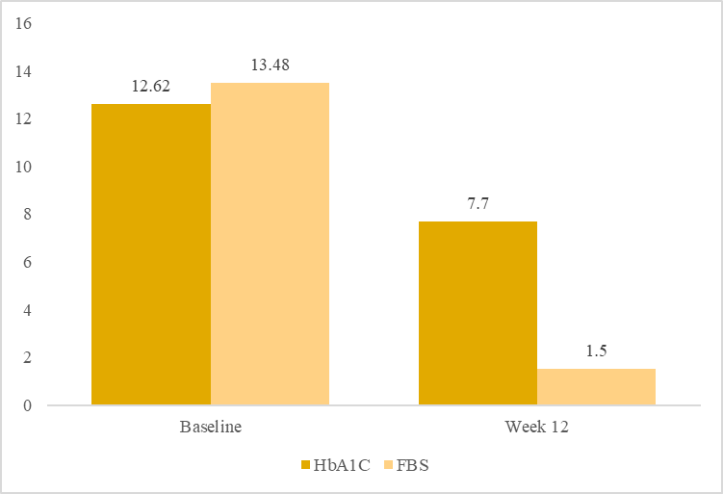
Figure 1. Metformin Effect on Glycemic Indices

Discussion. Our study revealed that metformin treatment in a dose of 500 mg BD , lowered HbA1c from baseline to week 12, highly significantly.The level of FBS was also reduced by metformin at end of week 12 highly significantly. These findings corroborated with study by (Izadi et al.,2021) which showed decreased HbA1c as well as FBG at end of 12 weeks.

