**Colloidal Mesoporous Silica Nanoparticles as Strong and Degradable Bio-adhesives**

*Joo-Hyung KimA, Hodae KimA, Youngjin ChoiA, Doo Sung LeeA, Jaeyun KimA,B,C, Gi-Ra YiA*

ASchool of Chemical Engineering, BDepartment of Health Sciences and Technology, Samsung Advanced Institute for Health Science & Technology (SAIHST), and CBiomedical Institute for Convergence at SKKU (BICS), Sungkyunkwan University, Suwon 16419, Republic of Korea.

Sub-100 nm colloidal mesoporous silica (CMS) nanoparticles are evaluated as an adhesive for hydrogels or biological tissues. Because the adhesion energy is proportional to the surface area of the nanoparticles, the CMS nanoparticles could provide a stronger adhesion between two hydrogels than the nonporous silica nanoparticles. In the case of 50 nm CMS nanoparticles with a pore diameter of 6.45 nm, the maximum adhesion energy was approximately 35.0 J/m2 at 3.0 wt %, whereas the 10 wt % nonporous silica nanoparticle solution showed only 7.0 J/m2. Moreover, the CMS nanoparticle solution had an adhesion energy of 22.0 J/m2 at 0.3 wt %, which was 11 times higher than that of the nonporous nanoparticles at the same concentration. Moreover, these CMS nanoparticles are demonstrated for adhering incised skin tissues of mouse, resulting in rapid healing even at a lower nanoparticle concentration. Finally, the CMS nanoparticles had added benefit of quick degradation in biological media because of their porous structure, which may prevent unwanted accumulation in tissues.

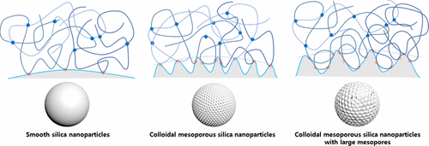

**References**

1. Kim, J.-H.; Kim. H.; Choi, Y.; Lee, D. S.; Kim. J.; Yi, G.-R. (2017) Colloidal Mesoporous Silica Nanoparticles as Strong Adhesives for Hydrogels and Biological Tissues. ACS Appl. Mater. Interfaces 9, 31469-31477