Repurposing Cyclovirobuxine D as a Novel Inhibitor of Colorectal Cancer Progression via Modulating the CCT3/YAP Axis
Yiman Liu¹, Shuangshuang Yin¹, Yingying Shao², Jiayan Huang¹, Haiyang Yu^{1*}

State Key Laboratory of Component-based Chinese Medicine, Tianjin University of
Traditional Chinese Medicine¹, Tianjin, China;
School of Medicine, Nankai University², Tianjin 300071, China.

Background and aims. Colorectal cancer (CRC) ranks second in mortality worldwide and requires effective and affordable remedies. Cyclovirobuxine D (CVB-D) is the main effective component of Huangyangning tablet, an approved traditional patent medicine, which is mainly used for cardiovascular treatment. As a multibioactive natural compound, CVB-D possesses underlying anticancer activities.

Methods. Cell viability and clone-forming ability were determined in human CRC lines. Western blot, immunofluorescence assay, transmission electron microscopy and senescence-associated β-galactosidase (SA-β-Gal) staining were utilized to investigate cell autophagy and senescence. The molecular mechanisms were explored by virtual prediction and experimental validation. Patient-derived xenograft (PDX), dextran sulfate sodium salt (DSS), and azomethane (AOM)/DSS mouse models were employed for in vivo studies.

Results. CVB-D inhibited the growth and development of advanced CRC cells/mice by inducing autophagic and senescent activities through the chaperonin containing TCP1 subunit 3 (CCT3)/yes-associated protein (YAP) axis. CVB-D acted as a promising inhibitor of CCT3 by interacting with its ATP site. In PDX tumours, CVB-D showed potential therapeutic effects by targeting CCT3. Treatment with CVB-D alleviated the mouse model of colitis induced by DSS and attenuated AOM/DSS-induced formation of adenomatous polyps by its action on CCT3.

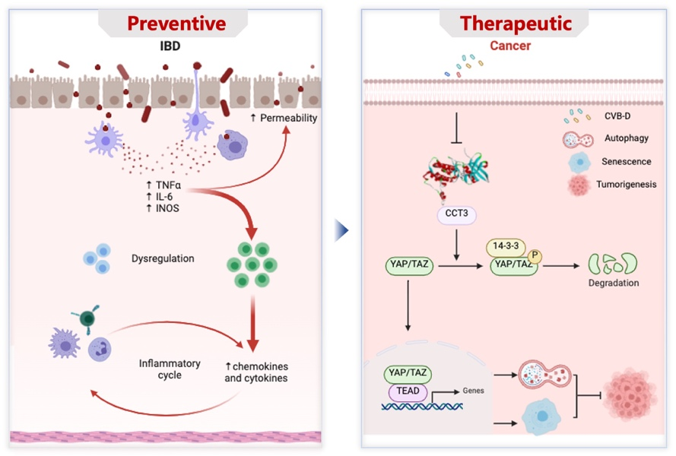
Figure 1. CVB-D impedes CRC progress by regulation of autophagy and senescence machinery via targeting CCT3. In terms of preventive effect, CVB-D alleviates DSS-induced murine colitis and attenuates AOM/DSS-induced adenomatous polyps formation.

Conclusion/Discussion. Our study has provided a scientific basis for the suggestion that CVB-D may be recognized as a prospective drug candidate for the therapy of CRC in patients.

Acknowledgements. This work was supported by Natural Science Foundation of Tianjin Municipality (No. 23JCJQJC00040), National Natural Science Foundation of China (No. 82274154), Science and Technology Project of Haihe Laboratory of Modern Chinese Medicine (No. 22HHZYSS00008), and Natural Science Foundation of Tianjin Municipality (No. 23JCZXJC00150).

References:
(1) Bray, F. et al (2024) Global cancer statistics 2022: GLOBOCAN estimates of incidence and mortality worldwide for 36 cancers in 185 countries. CA: a Cancer Journal for Clinicians, 56:23-33.
(2) Phan, T. et al (2022) Targeting CDK4 and CDK6 in cancer. Nature Reviews Cancer, 22: 356-372.

