**Human-Relevant Placenta-on-a-Chip Models as Alternatives to Animal Studies on Placentation and Pregnancy Complications**

Iman Akbarzadeh1, Mehran Dabiri2, Fatemeh Heidari1, Claire Richards1, Lana McClements1

1School of Life Sciences, Faculty of Science, University of Technology Sydney, Australia

2 School of Biomedical Engineering, Faculty of Engineering and Information Technology, University of Technology Sydney, Australia

**Background and aims.** Despite their use in placental research, animal models do not adequately recapitulate human placental development due to differences in structure and function. We previously developed a 3D placenta-on-a-chip model, which deciphered a new mechanism of maternal-fetal communication involving the immunophilin protein, FKBPL1. This study aims to further improve the complexity of this model system by incorporating multiple human placental cell types, including trophoblasts, stromal, immune, and endothelial cells2, and elucidate the intercellular crosstalk, therefore contributing to the 3Rs in animal research.

**Methods.** The first-generation placenta-on-a-chip model co-cultured the first-trimester trophoblast cells, ACH-3Ps, with human umbilical vein endothelial cells (HUVEC) and collagen within a commercially available microfluidics chip (AIM Biotech, Singapore) and investigated mechanisms of interaction under inflammatory conditions typical for preeclampsia 1. Our next-generation in-house fabricated placenta-on-a-chip has been designed with single-, dual-, and triple-channel configurations that can be spatially organized with trophoblasts, endothelial cells, stromal cells, or immune cells. We designed the chip to include lateral treatment ports and a rail-based central channel (1300 µm width with 500 µm side channels; 250 µm height) to aid in the containment of hydrogels. The device was designed in SolidWorks (2023), 3D-printed through MiiCraft, cast in PDMS, and bonded to glass using oxygen plasma.

**Results.** We successfully fabricated a stable and reproducible placenta-on-a-chip platform that expands on the capabilities of previous models by allowing spatially controlled integration of up to four distinct cell populations (first trimester trophoblast cell, human uterine microvascular endothelial cells with human uterine smooth muscle cells and fibroblasts) as well as directional delivery of soluble cues through dedicated treatment channels. The rail-based design offers structural support for continued 3D matrix confinement, enabling real-time monitoring of cell migration, trophoblast-endothelial interaction representative of maternal-fetal communication, and stromal/immune cell support of this process (Figure 1). The individual cell function will be assessed using immunofluorescence in terms of cell migration and network formation under normal, hypoxic, or pro-inflammatory conditions.

**Conclusion/Discussion.** Our advanced and multicellular placenta-on-a-chip system provides improved complexity, and it is a scalable, animal-free platform for investigating cellular and molecular processes important for placental development and function towards healthy pregnancy.

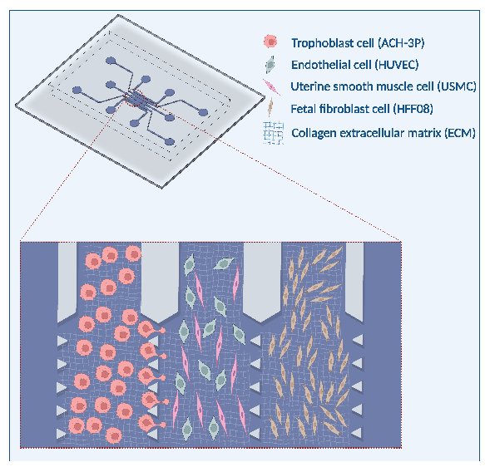

**References:**

(1) Ghorbanpour SM, et. al. A placenta-on-a-chip model to determine the regulation of FKBPL and galectin-3 in preeclampsia. Cell Mol Life Sci. 2023, 80(2), 44.

(2) Elzinga FA, et. al. Placenta-on-a-Chip as an In Vitro Approach to Evaluate the Physiological and Structural Characteristics of the Human Placental Barrier upon Drug Exposure: A Systematic Review. J Clin Med. 2023, 12(13), 4315.

*Figure 1. Schematic of the next-generation placenta-on-a-chip models consisting of multiple different placental cell types and two treatment channels.*