**Polymer-Modified Lipid Nanoparticles with Microenvironment-Responsive Graded Release for Amplified Photodynamic Therapy Through Tumor Vascular Normalization**

Ruoyu Shen1, **Peirong Li1**, Fuqiang Hu1, Jian Ji2, and Hong Yuan1

College of Pharmaceutical Science, Zhejiang University1, Hangzhou, Zhejiang Province, People’s Republic of China.

Department of Polymer Science and Engineering, Zhejiang University2, Hangzhou, Zhejiang Province,

People’s Republic of China.

**Background and aims.** Photodynamic therapy (PDT) is a promising cancer treatment with minimal invasiveness and low systemic toxicity. However, its efficiency is greatly limited by the tumor microenvironment (TME), especially the oxygen-starved condition caused by abnormal tumor vasculature. Tumor vascular normalization (TVN) is expected to reshape TME and enhance PDT efficacy. This study aimed to develop a composite nanodrug, PEVM NPs, combining TVN and PDT to improve anti-tumor efficiency.

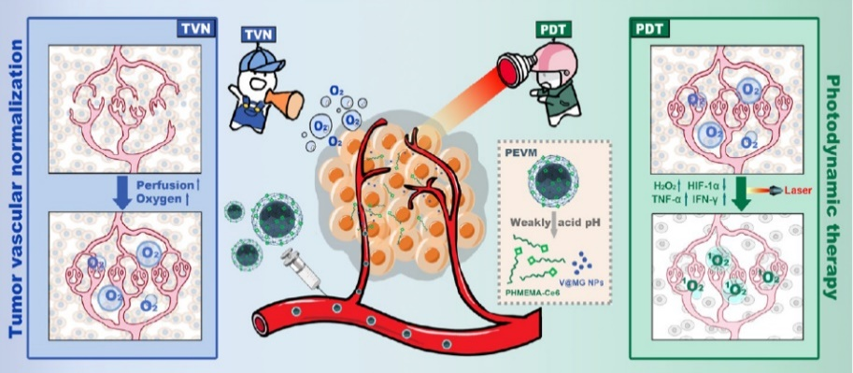

**Figure 1.** Composite Nanodrug, PEVM, Improved Anti-Tumor Efficiency of PDT by Promoting TVN, Remodelling Tumor Microenvironment, and Thus Increasing Oxygen Perfusion and Immune Response.

**Methods.** PEVM NPs were designed with a lipid nanoparticle core for sustained release of anti-angiogenic drugs and a pH-sensitive polymer shell linked to a photosensitizer Ce6. Characterization included NMR, TEM, and DLS. In vitro assays evaluated cellular uptake, ROS generation, and cytotoxicity in 4T1/HUVEC cells. In vivo studies in 4T1 tumor-bearing mice assessed biodistribution, tumor suppression, metastasis inhibition, vascular normalization (via FITC-dextran perfusion), and immune modulation (IHC, ELISA).

**Results.** PEVM NPs exhibited pH-responsive disintegration (pH 6.5), releasing Ce6 and V@MG NPs and showed favorable anti-tumor efficiency. In vitro and in vivo experiments demonstrated that PEVM NPs could increase oxygen perfusion through TVN, enhance PDT efficacy, and activate anti-tumor immune responses. The nanodrug also effectively inhibited tumor growth and metastasis, prolonged overall survival, and improved the tumor immune microenvironment.

**Conclusion/Discussion.** PEVM synergizes TVN and PDT via microenvironment-responsive graded release. TVN improves oxygen supply and immune infiltration, while PDT enhances tumor cell ablation. This dual strategy overcomes TME limitations, offering a promising approach for solid tumor therapy. The integration of pH-sensitive delivery and endogenous oxygen regulation highlights translational potential for combinatorial nanomedicine.

**Acknowledgements:** We acknowledge the contributions of all team members in Hu&Yuan’s lab and the facilities provided by Zhejiang University.

**References:**

1. Jain, R. K. (2000) Nature 407:249−257
2. Di Mascio, P. et al (2019) Chem. Rev 119:2043−2086
3. Zhou, Y. et al (2021) Nanoscale Horiz 6:120−131
4. Wang, D. et al (2019) Adv. Mater 31 No. e1901893
5. Zhu, D. et al (2020) Angew. Chem 59:13836−13843