Evaluating Potential Treatments Targeting Angiogenesis in Preeclampsia

Fatemeh Heidari¹⁴, Iman Akbarzadeh^{1,4}, Ahmed Elkashif ², Tracy Robson³, Helen O McCarthy², Kristine McGrath¹, Lana McClements^{1,4*}
1. School of Life Sciences, Faculty of Science, University of Technology Sydney, NSW, Australia
2. School of Pharmacy, Queen's University Belfast, Medical Biological Centre, 97 Lisburn Road, Belfast BT9 7LB, UK.
3. School of Pharmacy and Biomolecular Sciences, Royal College of Surgeons in Ireland, University of Medicine and Health Sciences, Dublin, Ireland.
4. Institute for Biomedical Materials and Devices, Faculty of Science, University of Technology Sydney, NSW, Australia.
*Corresponding Author: lana.mcclements@uts.edu.au

Background and aims. This study established a novel in vivo model of preeclampsia by inducing angiogenic imbalance (high sFlt-1/low FKBPL) (Figure 1) and evaluated the impact of potential treatments for preeclampsia in an in vivo model ª.

Methods. Wild-type (WT) and fkbpl^{+/-} C57BL/6N mice were administered sFlt-1 (5μg) using non-viral gene delivery system, RALA, as nanoparticles, intravenously on embryonic day (E)8 and 12 and randomly allocated to i) control(n=10), ii) exercise(n=5), iii) metformin(n=7) or iv) FKBPL-based peptide, AD-01(n=8) groups. Echocardiography and placenta/embryo weight were determined, and hearts/placentas/embryos were harvested on day E18.

Results. RALA-sFlt-1 (<100 nM, 40–60 mV) reduced embryo weight (p<0.0001) in WT (female/male: p<0.0001) and fkbpl⁺/⁻ mice (female: p<0.05; male: p<0.01), compared to vehicle control. Exercise improved embryo weight only in sFlt-1 fkbpl⁺/⁻ mice (female: p<0.001; male: p<0.0001). AD-01 improved embryo weight in sFlt-1 WT (female/male: p<0.05) but reduced it further in fkbpl⁺/⁻ (female/male: p<0.01). Metformin had no effect. Placental efficiency was reduced in WT with RALA-sFlt-1 (female: p<0.01; male: p<0.001) but not in fkbpl^{+/-} mice. Nevertheless, in sFlt-1 fkbpl⁺/⁻ mice, exercise increased placental efficiency (female: p<0.001; male: p<0.05), while AD-01 decreased it (female: p<0.05; male: p<0.01). Placental sFlt-1 levels were reduced in sFlt-1 fkbpl⁺/⁻ females (p<0.01), trended higher in sFlt-1 WT (p=0.07), compared to vehicle controls; exercise further decreased placental sFlt-1 concentration in fkbpl⁺/⁻ (female: p<0.05; male: p<0.01). Metformin had no effect. Pregnancy increased cardiac output in WT vs. non-pregnant controls (p<0.0081), but sFlt-1 reduced it (p<0.044). In WT mice, exercise restored cardiac output (p<0.0015); metformin showed a trend (p<0.054). Metformin reduced cardiac sFlt-1 levels in fkbpl⁺/⁻ mice compared to the sFlt-1 fkbpl^{+/-} control mice (p<0.035).

Conclusion/Discussion. Our nanoparticle-induced preeclampsia model of angiogenic imbalance impairs maternal cardiovascular and fetal outcomes; exercise, metformin, and AD-01 show variable and fkbpl-dependent therapeutic effects.

References:
ª McNally R, Alqudah A, McErlean EM, Rennie C, Morshed N, Short A, McGrath K, Shimoni O, Robson T, McCarthy HO, McClements L. Non-viral gene delivery utilizing RALA modulates sFlt-1 secretion, important for preeclampsia. Nanomedicine. 2021 Sep 1;16(22):1999-2012.

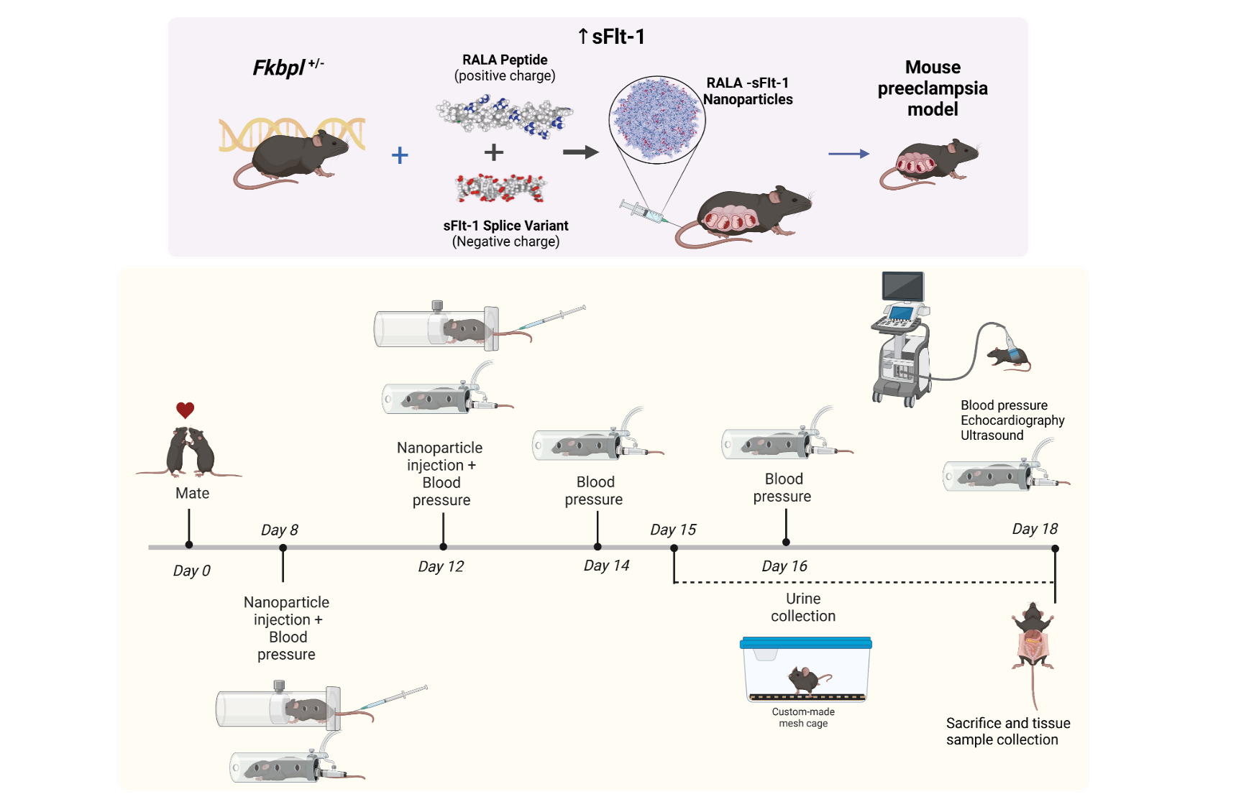
Figure 1.Schematic illustration of the animal work (ETH 22-7673). Female FKBPL knocked down mice (one copy of FKBPL knocked down, (fkbpl^{+/-}) and wild-type control (fkbpl^{+/+}) female mice with fkbpl^{+/+} male mice mating. Female mice will then receive sFlt-1 containing nanoparticles on day 8 and day 12 of gestation to induce preeclampsia phenotype and blood pressure will be measured on gestational days 8, 12, 14, 16, and 18 (before sacrifice). Simultaneously at day 8 of gestation, the mice will be administered potential treatments before collection of blood and tissue samples at the endpoint at day 18 of gestation. Figure produced in Biorender.

