**Swelling and Aggregation Dynamics in Au@PNIPAM Colloid Systems: A Capacitor-Based Temperature Jump Study**

*Ben Tadgell A, Ekaterina Ponomareva B, Matthias Karg B, Paul Mulvaney A*

A ARC Centre of Excellence in Exciton Science, The University of Melbourne, Melbourne, Australia; B Universität Dusseldorf, Dusseldorf, Germany.

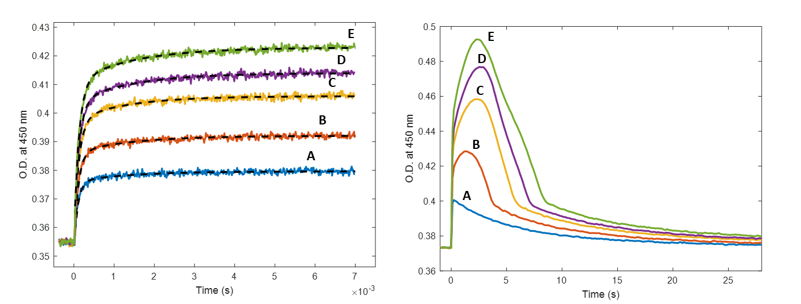

**Fig. 1.** Temperature-jump spectra for an Au@PNIPAM system. (Left) 7 ms timescale experiment overlaid with double-exponential fits represents the particle deswelling dynamics. (Right) 30 s timescale experiment represents aggregation dynamics. Temperature jumps: 31.0°C → 33.5°C (Blue, A), 31.0°C → 34.6°C (orange, B), 31.0°C → 36.0°C (yellow, C), 31.0°C → 37.1°C (purple, D), 31.0°C → 38.9°C (green, E).

Capacitor-based temperature-jump spectroscopy is an extremely useful tool for monitoring dynamics in biochemical and chemical systems that occur on the scale of milliseconds. We have applied this technique to analyse dynamics in a colloid system of PNIPAM-coated Au nanoparticles1 – which undergo two types of conformational changes upon a very fast change in temperature over the polymer Lower Critical Solution Temperature (LCST) (**Fig. 1**).

First: a deswelling transition as the polymer adjusts to a collapsed, more hydrophobic state. Under certain conditions, the colloid nanoparticles will then aggregate, before coming apart as the solution cools. Both these processes are entirely reversible, the kinetics are reproducible, and the dynamics were extensively modelled and measured based on changes in turbidity of the system.

By carefully designing kinetic models for these phenomena – we have determined how a range of parameters (particle diameter, cross-linker density, particle concentration, [KCl], [SDS], pH etc.) affect the various components of these transitions. These parameters are vital to control the self-assembly of Au@PNIPAM particles into optically active super-structures.2 The outcome shows the potential of temperature-jump spectroscopy to understanding kinetics for colloidal nanoparticle conformational changes and self-assembly.

**References**

1. Contreras-Caceres, R *et al*., *Adv. Mater.* **2008,** *20* (9), 1666-1670.
2. Karg, M.; Hellweg, T.; Mulvaney, P., *Adv. Funct. Mater.* **2011,** *21* (24), 4668-4676.