Strengthening pharmacology education through establishing an academic support and quality assurance office
Cara de Moura-Cunningham¹, Natalie Schellack¹, Werner Cordier¹. Dept of Pharmacology, Univ of Pretoria¹, Pretoria, South Africa.
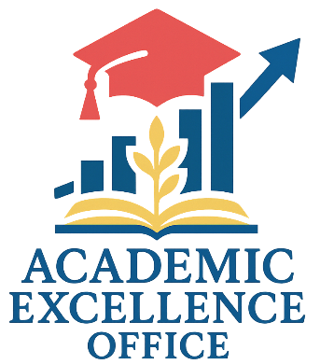
Introduction. Academics of the University of Pretoria, like others in South Africa, face challenges balancing academic responsibilities (Dlamini et al, 2024). Many faculty members are subject-matter experts, though they lack formal training in education and administration (Barnes et al, 2021). This, coupled with staff shortages and institutional expectations, increases workloads and amotivation.
Aims. To establish the Academic Excellence (AE) Office’s brand and scope of work within the Department of Pharmacology, supporting educational administration and quality.
Methods. A situational analysis was conducted across all Pharmacology modules presented to the Faculties of Natural and Agricultural Sciences and Health Sciences to determine system strengthening outcomes. This identified teaching needs, gaps, and administrative challenges. Various modalities were piloted, including a postgraduate internship, artificial intelligence, automation, and change management.
Results. The situational analysis identified unassigned lectures (due to staff turnover), lack of a central resource repository, redundant administrative tasks, and insufficient monitoring systems. Initial feedback was positive, with staff expressing a need to further reduce the administrative burden.
Discussion. Pilot interventions improved student monitoring through attendance tracking, early risk identification, and remedial support, while bi-monthly teaching meetings and postgraduate training fostered a culture of excellence. The AE Office presents a scalable model for strengthening administration and teaching, with future plans to expand automation, AI integration, and curriculum mapping.

Barnes N et al (2021) SA Journal of Human Resource Management 19:0
Dlamini NG and Dlamini ND (2024) Discover Education 3:9-18

