**Synthesis of 2D materials using liquid metal solvents**

Dr Torben Daeneke,

School of Engineering, RMIT University, Melbourne, Australia

Most metals feature an atomically-thin oxide layer at the metal air interface.[1] This also applies to liquid metals including molten tin, indium, gallium and their alloys. In many cases this oxide layer grows in a self-limiting reaction providing a pathway towards atomically-thin, two-dimensional materials.[2] This talk will discuss different liquid metal-based synthesis strategies for 2D materials and will highlight how large area ultrathin sheets can be isolated form the liquid metal interface. Interestingly, liquid metal-based synthesis strategies allow the isolation of atomically-thin nanosheets of non-stratified materials, providing an opportunity for drastically increasing the number of accessible 2D materials.[2] A variety of liquid metal derived materials will be discussed in this talk, including metal oxides,[2, 3] chalcogenides,[4] nitrides and phosphates[5]. The developed materials are ideally suited for a variety of applications including in electronics, piezotronics and catalysis.

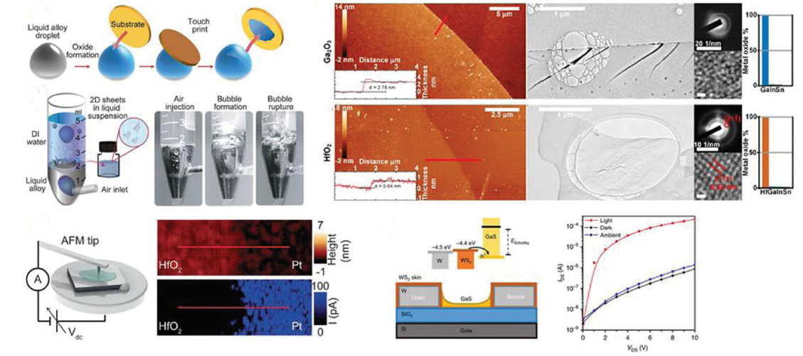

Figure 1: Overview of liquid metal synthesis approaches, AFM and TEM characterizations of isolated sheets and evaluation of their electronic properties.

**References:**

T. Daeneke, K. Khoshmanesh, N. Mahmood, I. A. de Castro, D. Esrafilzadeh, S. J. Barrow, M. D. Dickey, K. Kalantar-zadeh, Liquid metals: fundamentals and applications in chemistry Chemical Society Reviews, 2018 ,47, 4073-4111

2. Zavabeti, A.; Ou, J. Z.; Carey, B. J.; Syed, N.; Orrell-Trigg, R.; Mayes, E. L. H.; Xu, C.; Kavehei, O.; O’Mullane, A. P.; Kaner, R. B.; Kalantar-zadeh, K.; Daeneke, T., A liquid metal reaction environment for the room-temperature synthesis of atomically thin metal oxides. Science 2017, 358 (6361), 332-335.

3. Daeneke, T.; Atkin, P.; Orrell-Trigg, R.; Zavabeti, A.; Ahmed, T.; Walia, S.; Liu, M.; Tachibana, Y.; Javaid, M.; Greentree, A. D.; Russo, S. P.; Kaner, R. B.; Kalantar-Zadeh, K., Wafer-Scale Synthesis of Semiconducting SnO Monolayers from Interfacial Oxide Layers of Metallic Liquid Tin. ACS Nano 2017, 11 (11), 10974-10983.

4. Carey, B. J.; Ou, J. Z.; Clark, R. M.; Berean, K. J.; Zavabeti, A.; Chesman, A. S. R.; Russo, S. P.; Lau, D. W. M.; Xu, Z.-Q.; Bao, Q.; Kavehei, O.; Gibson, B. C.; Dickey, M. D.; Kaner, R. B.; Daeneke, T.; Kalantar-Zadeh, K., Wafer-scale two-dimensional semiconductors from printed oxide skin of liquid metals. Nature Communications 2017, 8, 14482.

5. Syed, N.; Zavabeti, A.; Messalea, K. A.; Della Gaspera, E.; Elbourne, A.; Jannat, A.; Mohiuddin, M.; Zhang, B. Y.; Zheng, G.; Wang, L.; Russo, S. P.; Dorna, E.; McConville, C. F.; Kalantar-Zadeh, K.; Daeneke, T., Wafer-Sized Ultrathin Gallium and Indium Nitride Nanosheets through the Ammonolysis of Liquid Metal Derived Oxides. Journal of the American Chemical Society 2019, 141, 1, 104-108

Email: Dr Torben Daeneke, Torben.daeneke@rmit.edu.au