**Existence of the Navier slip condition for liquid flows around nanoparticles**

*Jesse F. CollisA, Selim OlcumB, Debadi ChakrabortyA, Scott R. ManalisB, John E. SaderA*

AARC Centre of Excellence in Exciton Science, School of Mathematics and Statistics, The University of Melbourne, Victoria 3010, Australia; BKoch Institute for Integrative Cancer Research, Massachusetts Institute of Technology, Cambridge, MA 02139, USA.

*Synopsis*

The Navier slip boundary condition is regularly used in nanoscale liquid flows to characterise the interaction at the liquid-solid interface. In this talk we present a standardised experimental protocol to measure the slip length on individual nanoparticles with exquisite precision. A constant slip length—independent of particle size—of 2.7 $±$ 0.6 nm is found, providing evidence of the Navier slip conditions existence in liquid flows.

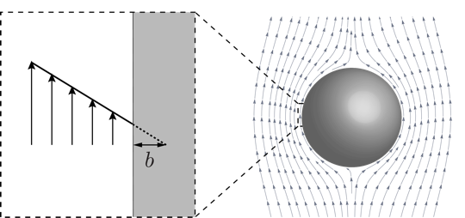*Introduction*

The use of the Navier slip condition (see Fig. 1) in gas flows is justified rigorously from Boltzmann’s kinetic theory of gases. No such parallel framework exists for liquid flows where molecular dynamics simulations provide the strongest evidence for the existence of the Navier slip condition. As dictated by kinetic theory, the Navier slip length is a constitutive property (independent of particle size), that holds when the flow is *unconfined* (flow away from the surface must be in a continuum state)*.*

**Fig. 1.** Streamlines of liquid flowing past a sphere at zero Reynolds number. The slip length, $b$, is the extrapolated distance into the solid surface where the no-slip boundary condition would hold.

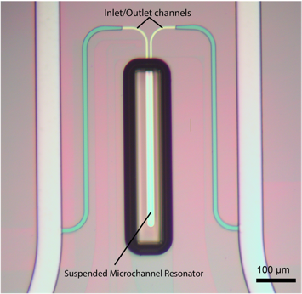*Methods*

In this talk, we present a standardised experimental protocol using a new modality of suspended microchannel resonators (SMRs) to measure the slip length on individual nanoparticles, satisfying the conditions above. SMRs are cantilevered inertial mass sensors with a fluid channel embedded in the interior of the device that allow ultra-sensitive measurements of suspended particles in liquid environments1,2; see Fig. 2. When a negatively buoyant nanoparticle is introduced into this channel, the particle drives a flow in the liquid which is intimately connected to the boundary condition at the liquid-solid interface3—this is quantified with a new theoretical framework.

**Fig. 2.** Optical micrograph of a Suspended Microchannel Resonator and inlet/outlet channels. The SMR contains a fluid channel embedded in its interior.

*Results*

Experiments consisting of repeat measurements on individual gold nanoparticles are collected by flowing a single particle back and forth through the SMR. Hundreds of measurements are performed on each nanoparticle to overcome the frequency noise inherent in these experiments. A constant slip length of 2.7 $±$ 0.6 nm is found which, crucially, is independent of particle size, thus providing experimental validation of the Navier slip condition for liquids.

The authors gratefully acknowledge support of the ARC Centre of Excellence in Exciton Science (CE170100026), the Australian Research Council Grants Scheme, an Australian Postgraduate Award and the Institute for Collaborative Biotechnologies through grant W911NF-09-0001 from the US Army Research Office.

*References*

1. Burg, T. P. *et al.* (2007) Weighing of biomolecules, single cells and single nanoparticles in fluid, Nature, 446, 1006-1069.
2. Olcum, S., Cermak N., Wasserman, S. C. & Manalis, S. R. (2015) High-speed multiple-mode mass-sensing resolves dynamic nanoscale mass distributions, Nat. Commun., 6, 7070.
3. Collis, J. F., Chakraborty, D. & Sader, J. E. (2017) Autonomous propulsion of nanorods trapped in an acoustic field, J. Fluid Mech., 825, 29-48.