Investigating the role of IA65 on thapsigargin-induced IL-6 gene expression via ORAI1
Jihye Han¹, Farzaneh Forouz¹, Sarah J. Roberts-Thomson¹, Gregory R. Monteith¹ and Mélanie Robitaille¹
Sch of Pharm, Univ of Queensland¹, Brisbane, QLD, Australia.
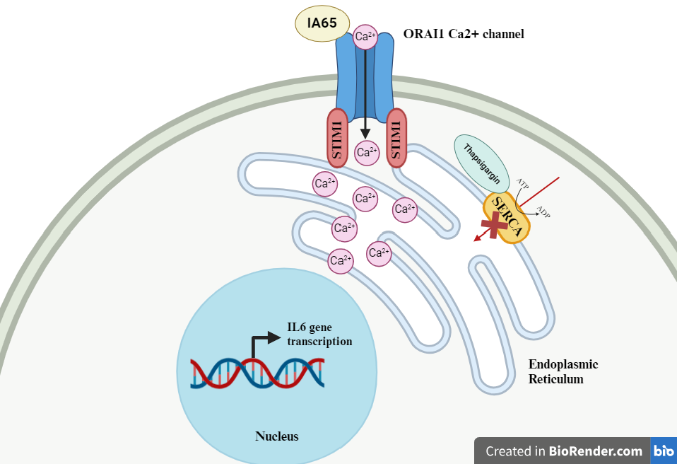
Introduction. Store-operated calcium entry (SOCE) is a central mechanism in maintaining cellular calcium balance. The ORAI1 calcium channel is the key channel regulating SOCE and its activation by thapsigargin is linked to the regulation of IL-6 gene transcription (Robitaille et al, 2022). IA65, a selective pharmacological enhancer of ORAI1 has been recently described (Azimi et al, 2020), but its effect on ORAI1-mediated gene transcription is unknown.
Aims. Our study aimed to assess the effect of IA65 on thapsigargin-induced IL-6 gene expression and its dependency on ORAI1 function.
Methods. ORAI1 protein expression was disrupted in MDA-MB-231 and MDA-MB-468 cells by CRISPR/Cas9. A submaximal concentration of thapsigargin was used to induce ORAI1-mediated SOCE. IL-6 gene expression level was quantified by RT-qPCR.
Results. Thapsigargin treatment increased IL-6 gene expression in an ORAI1 dependent manner. Addition of ORAI1 enhancer IA65 treatment did not change IL-6 gene expression.
Discussion. ORAI1 expression/function is altered in many diseases including asthma and cancer (Azimi et al, 2020). The discovery of the ORAI1 enhancer IA65 has opened up new opportunities to further investigate ORAI1 and its Ca²⁺ regulated mechanisms, including gene transcription. Although IA65 displays selectivity towards ORAI1 and weak inhibition of the ORAI3 isoform (Azimi et al, 2020), it is still poorly characterised. Our study demonstrated that IA65 treatment was ineffective at increasing thapsigargin induced IL-6 expression.

Azimi I et al (2020) ACS Pharmacol Transl Sci 3:135-147.
Robitaille M et al (2022) Int J Mol Sci 23:5867.

