**Fundamental investigations of diamond wire sawing of silicon wafers**

*Shreyes N MelkoteA*

A G.W. Woodruff School of Mechanical Engineering, Georgia Institute of Technology, Atlanta, USA.

Introduction: This keynote will present recent work by the speaker’s group on fundamental studies of the diamond wire sawing process used to slice single and multi-crystalline silicon wafers for solar cell applications. Specifically, the talk will focus on the role of abrasive shapes, microstructural defects, and the role of cutting fluid on the mode of material removal and on the surface and subsurface damage produced in diamond scribing studies that simulate the grit-material interaction in diamond wire sawing. The talk will conclude with remarks on possible areas of future work.

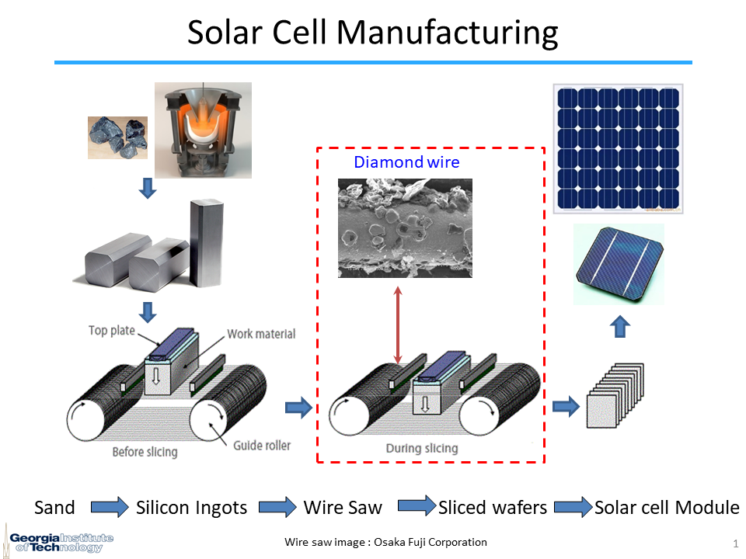

**References**

1. Kumar, A., Melkote, S.N. (2017). Diamond wire sawing of solar silicon wafers: a sustainable manufacturing alternative to loose abrasive slurry sawing. Procedia Manufacturing, 21 (2018) 549-566.