Fabrication of microneedle arrays for the dermal delivery of therapeutics
Eleanor M Mills¹, Mark P Del Borgo¹. Dept of Pharmacology, Monash Univ¹, Clayton, VIC, Australia.

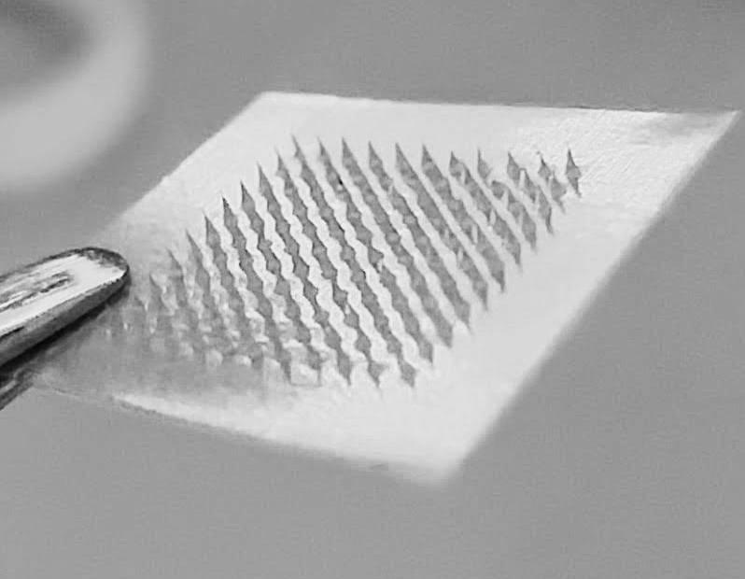
Introduction. No one enjoys needles. In fact, hypodermic needles and liquid vaccines struggle with patient compliance, healthcare staff safety, and accessibility in rural communities. Dissolvable microneedles (MNs), which dissolve upon insertion and release drug into the dermis, are an alternative to traditional vaccination that is pain-free as they are not long enough to come into contact with nerves. Additionally, they are self-administrable, sharps and biohazard waste-free, have lower microbial infiltration, do not require cold-chain storage, and deliver cargo directly to dermal immune cells.
Aims. Formulate dissolvable microneedles from carboxymethylcellulose (CMC), with/without a model compound, and assess the ability to perforate and dissolve in artificial and ex vivo skin models.
Methods. MN arrays were formed in polydimethylsiloxane moulds from low viscosity CMC. Rhodamine B (RhB MN) was incorporated into the tips as a model compound. For perforation efficiency, MNs were applied to stacked layers of Parafilm, then perforations per layer quantified. To assess dissolution, marmoset skin or parafilm was placed on agarose and warmed PBS (37°C) to emulate physiological conditions, then RhB MNs were applied for up to 60 min. The skin was then fixed and embedded, and sections were taken and imaged on an EVOS microscope. After application to parafilm, RhB MNs were dissolved in Milli-Q water and the amount of rhodamine B remaining quantified by absorbance.
Results. RhB MNs significantly decreased deformation after application to Parafilm by ~20%, compared to CMC alone MNs (n = 12, p<0.0001). 88% of RhB MNs microprojections perforated one layer of parafilm (127μm), and 27% perforated two (254μm). At 30min post-insertion through parafilm, ~60% of RhB dissolved into agarose. Contrastingly, RhB MNs did not penetrate the stratum corneum of marmoset skin with no observable deposition of RhB.
Discussion. Surprisingly, the incorporation of a model compound into CMC MNs improved the structural integrity, as seen by increased perforation efficiency. 88% of RhB MN microprojections could perforate a depth equivalent to the dermal layer of the skin, and showed effective release of cargo in parafilm-based models. This is the first documentation of the use of excised marmoset skin in this field, but unfortunately perforation was not seen. As this contrasts with the success of the parafilm model, may be attributable to the model chosen rather than the microneedles themselves.

