Targeting PDE and TRPV1 with Diosmetin: Mechanistic Insights from Rosemary Extract Sara Naqvi1,2, Najeeb Ur Rehman 3, Iqbal Azhar1, Syed Hani Abidi4* & Amber Palla5*.
1. Department of Pharmacognosy, Faculty of Pharmacy and Pharmaceutical Sciences, University of Karachi. sara.naqvi@iqra.edu.pk (Ph.D.), iazhar@uok.edu.pk (Ph.D). 2. Department of Pharmacy, Iqra university north campus. 3. Department of Pharmacology and Toxicology, College of Pharmacy, Prince Sattam Bin Abdulaziz University, Al Kharj Saudia Arabia. n_rehman5@hotmail.com (Ph.D). 4*. Department of Biomedical Sciences, Nazarbayev University School of Medicine, Kazakhstan. M.haniabidi@gmail.com (Ph.D). 5*. Department of Biological and Biomedical Sciences, The Aga Khan University, Karachi, Pakistan* amber.palla@aku.edu (Ph.D).

Corresponding authors:
Amber Hanif Palla5*, Ph. D Assistant Professor,
Department of Biological and Biomedical Sciences (Pharmacology), Medical college
The Aga Khan University, Karachi Tel: +92-021-34864564
Karachi, Pakistan; Email: amber.palla@aku.edu; amberpalla@yahoo.com

Abstract Introduction
Functional gastrointestinal disorders (FGIDs) are multifactorial conditions involving altered motility, abdominal pain, and visceral hypersensitivity, commonly seen in irritable bowel syndrome (IBS) [1]. Phosphodiesterase (PDE) inhibition [2] and transient receptor potential vanilloid 1 (TRPV1) [3] modulation regulate motility, visceral sensitivity, and pain, key features of IBS. Their convergence, through PDE-mediated smooth muscle relaxation and TRPV1-mediated nociception, offers a dual-target strategy for IBS management. Existing treatments are costly and cause adverse effects, limiting long-term compliance. Natural products, in contrast, are considered “side-effect neutralizing” due to their diverse phytochemicals and broad therapeutic efficacy. Within this context, rosemary and its methoxyflavone diosmetin were investigated for PDE inhibitory (PDEI), TRPV1 modulatory, and pharmacological activities, building on our earlier findings of rosemary’s gut modulatory potential [4].

Methodology

Ex vivo assays were performed on isolated rabbit jejunum to assess PDE inhibitory activity of hydro alcoholic extract of rosemary extract (Rs.Cr), while in vivo studies evaluated dose-dependent analgesic effects using hot plate in BALB/C mice and tail immersion method using in SD rats respectively. High pressure liquid chromatography

(HPLC) was employed for bioactive identification. Molecular docking and simulation studies were performed with PDE-4A and TRPV1. Diosmetin was subsequently validated via ex vivo assays. The Ethics Committee for Animal Care and Use (ECACU) of The Aga Khan University approved the current study with approval number 113-ECACU-BBS-22. All animal based studies adhered to the ARRIVE Guidelines for conducting and reporting animal research

Results

Rs.Cr relaxed carbachol (CCh; 1 µM)-induced contractions in rabbit jejunum using isolated tissue bath assembly. The CCh-mediated contractions were further examined for PDE involvement, where Rs.Cr shifted isoprenaline concentration–response curves to the left in a dose-dependent manner, similar to the standard PDE inhibitor papaverine (Fig 1). In hot plate and tail immersion assays, Rs.Cr produced dose-dependent analgesic effects at 50, 100, and 150 mg/kg, with the most pronounced effect at 150 mg/kg, comparable to tramadol, a standard opioid analgesic (Fig 2 & 3). RP-HPLC analysis confirmed the presence of diosmetin in Rs.Cr (Fig 4). To strengthen mechanistic insights, molecular docking and dynamics simulations were performed. Diosmetin showed stable binding with PDE4A (−6.961 kcal/mol), comparable to rolipram (Fig 5), a standard PDEI (−8.311 kcal/mol), and with TRPV1 (−8.239 kcal/mol), comparable to acetaminophen (−6.840 kcal/mol), a standard analgesic (Fig 7). These computational findings align with the observed analgesic effects of diosmetin. PDE inhibitory activity of diosmetin was further confirmed in ex vivo assays (Fig 8).

Conclusion

Rosemary extract (Rs.Cr) and its flavonoid diosmetin showed PDE inhibitory, TRPV1 modulatory, analgesic, and gut relaxant effects. Diosmetin’s strong binding with PDE4A and TRPV1 supports its dual-target role. These results highlight diosmetin as a promising, safer candidate for pain, inflammation, and IBS management.

References

- Camilleri, M., Diagnosis and treatment of irritable bowel syndrome: a review. Jama, 2021. 325(9): p. 865-877.

- Yuan, F., et al., Effect of phosphodiesterase‐4 inhibitor rolipram on colonic hypermotility in water avoidance stress rat model. Neurogastroenterology & Motility, 2022. 34(7): p. e14317.

- Mobasheri, A., et al., Targeting the TRPV1 pain pathway in osteoarthritis of the knee. Expert Opinion on Therapeutic Targets, 2024. 28(10): p. 843-856.

- Naqvi, S., et al., Unraveling the multi-faceted role of Rosmarinus officinalis L.(rosemary) and diosmetin in managing gut motility. Journal of ethnopharmacology, 2024. 332: p. 118395.

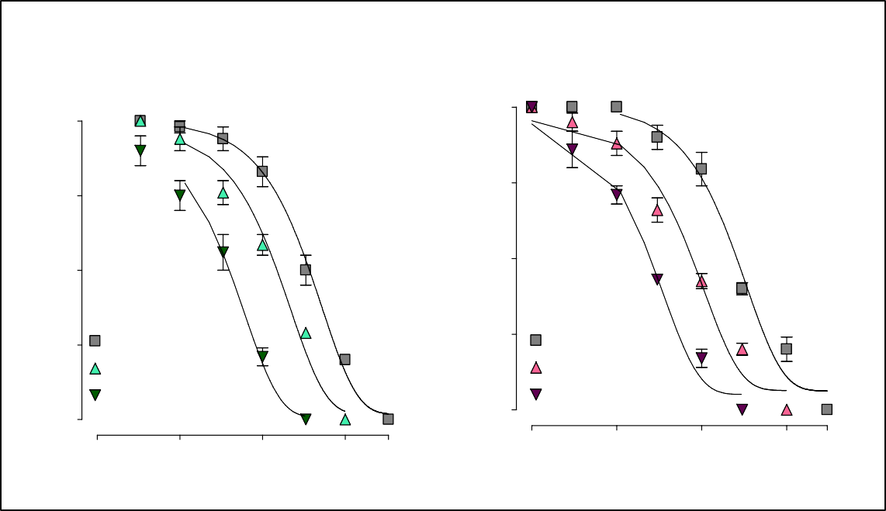
F
(A)
100
PDEI Effect of Rs.Cr in Rabbit Jejunum
(B)
100
75
75
50
50
25
Control
Rs.Cr (1 mg/mL)
Rs.Cr (3 mg/mL)
25
Control Papaverine (3 µ M)
Papaverine (10 µ M)
0
0.0003
0
0.003
0.03
0.3
1
0.001
0.01
0.1
1 3
[Isoprenaline] µM
[Isoprenaline] µM
% of Control
% of Control
ig. 1 (A-B): PDEI effect of Rs.Cr. Isoprenaline CRCs with and without increasing concentrations of Rs.Cr (A), and papaverine (B) constructed against CCh (1 µM)-induced contractions using the rabbit jejunum in an isolated tissue bath assembly. Rs.Cr shifted the isoprenaline curve to the left, at 1 and 3 mg/mL, indicating a PDEI activity in a similar manner caused by papaverine, a standard PDEI (A), similar to papaverine (PDEI) at doses of 3 µM and 10 µM (B). All experiments' means±SEM are shown by the values (n = 4-5). Abbreviations: Rs.Cr = Hydroethanolic extract of rosemary, CRC = concentration-response curves, PDEI = Phosphodiesterase inhibitors.

Fig. .2: Effect of Rs.Cr on percent increase in reaction time using hot plate test. Total rats used were 6 in each group. Data are presented as mean values (±SEM) from a group of six animals in each group. Abbreviations: Rs.Cr = Hydroethanolic extract of rosemary
Hot plate test of Rs.Cr
25
Sham = DW 10 mL/kg
Control = Tramadol 20 mg/kg
20 Rs.Cr 50 mg/kg
Rs.Cr 100 mg/kg
Rs.Cr 150 mg/kg
15

10

5

0
0
25
50
75
100
Concentration
% increase in reaction time

Fig. 3: Effect of
***
***
**
*
#
Assessment of analgesic activity

Vehicle =DW 10 ml/ kg Tramadol = 20 mg/ kg
Pretreatment
Post treatment
15

12

9

6

3

0
Rs.Cr (mg/kg)
Reaction time (sec)
Vehicle
Tramadol
50
100
200
Rs.Cr on percent increase in reaction time in tail flick test. Total animals used were 6 in each group. Data are presented as mean values (±SEM) from a group of six rats in each group. Data were statistically analyzed using one-way analysis of variance (ANOVA), followed by Tukey's post test; *, **, and *** reflects p<0.05, p<0.01 and
***p<0.001 vs diazepam (1 mg/kg). Time assessed 10 min for LDA = 600 sec, and 5 min for EPM = 300 sec. Abbreviations: Rs.Cr = Hydroethanolic extract of rosemary.
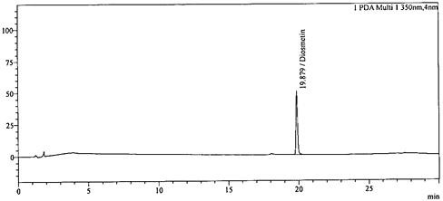
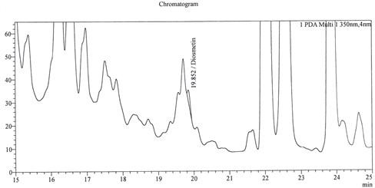
(A)
HPLC OF Rs.Cr & Diosmetin
(B)

Fig. 4 (A-B): HPLC of Rs.Cr & diosmetin. The presence of bioactive phytoconstituents belonging to class of flavonoids in Rs. Cr at 250 nm using RP C 18 (A and B). Fingerprints of known standard of the Rosemary; confirmed the presence of Diosmetin in Rs.Cr comparable to the retention times of Diosmetin 19.87 min. Numbers mentioned in the figure represent the Rt (min) of the respective compounds identified. HPLC samples were prepared in DMSO. Abbreviations: Rs.Cr = Hydroethanolic extract of rosemary (30:70); HPLC = High Pressure Liquid Chromatography; Rt = Retention time; DMSO = dimethyl sulfoxide
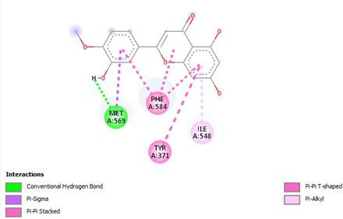
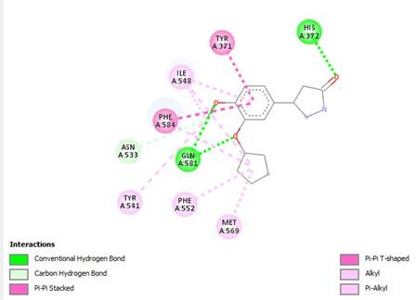
2D Diagram of Protein and Ligand
(A) PDE4A & Rolipram
(B) PDE4A & Diosmetin
Fig. 5: 2D-Visualization of the molecular interactions of PDE4A with flavonoids identified in plant extract; Diosmetin (B) and rolipram (A).
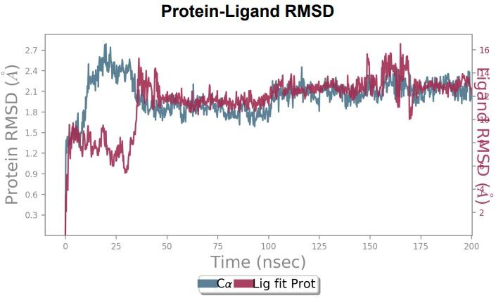

Fig. 6A: RMSD plot of C-alpha atoms for the diosmetin–PDE4A complex over a 200 ns MD simulation. Abbreviations: RMSD = Root mean square deviation; MD = Molecular dynamics; PDE4A = Phosphodiesterase 4A; ns = Nanoseconds; Å = Angstroms.

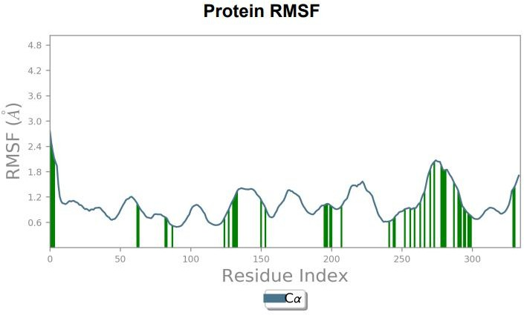

Fig. 6B. RMSF plot of PDE4A residues in complex with diosmetin over the 200 ns MD simulation, showing residue-wise atomic fluctuations in Å. Abbreviations: RMSF = Root mean square fluctuation; MD = Molecular dynamics; PDE4A = Phosphodiesterase 4A; ns = Nanoseconds; Å = Angstroms.

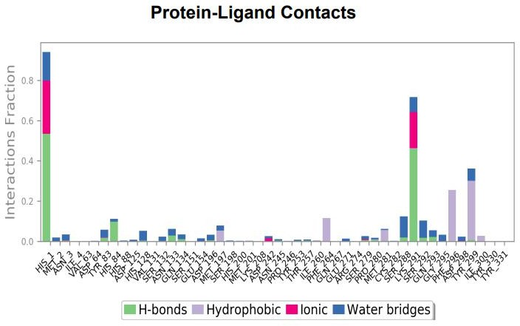

Fig. 6C: Interaction profile of diosmetin with key amino acid (a.a.) residues of the PDE4A during the Molecular Dynamics (MD) simulation. The x-axis shows the amino acid residues, and the y-axis represents the fraction of interactions with diosmetin. Each bar indicates the fraction of different interaction types (H-bonds, hydrophobic, ionic, and water bridges). Abbreviations: a.a
= Amino Acids; PDE4A = Phosphodiesterase 4A; MD = Molecular Dynamics; H-bonds = Hydrogen Bonds.
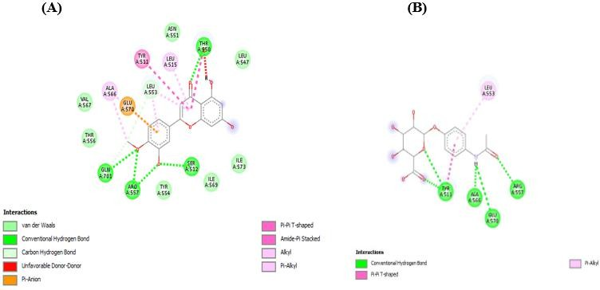
Fig. 7: 2D-Visualization of the molecular interactions of TRPVI (B) with diosmetin (A) identified in rosemary extract.

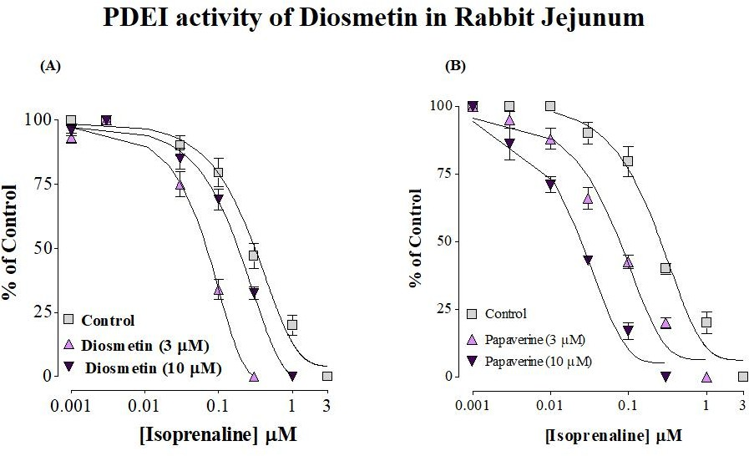
Fig. 8 (A-B) PDEI effect of diosmetin. Isoprenaline CRCs with and without increasing diosmetin concentrations (A), and papaverine (B) using rabbit jejunum in an isolated tissue bath assembly. CCh (1 mM)-induced contractions were dependently reduced by Isoprenaline. Diosmetin at doses of 3 and 10 µg/

mL reflecting the inhibitory response of isoprenaline with leftward shift (A), similar to papaverine (PDEI) at dose of 3 µM and 10 µM. The values expressed are mean±S.E.M taken from 3-4 preparations obtained from 3 different rabbits. Abbreviations: PDEI = Phosphodiesterase inhibitor.

