**Trace Element-Dictated Exosome Modules and Self-Adaptive Dual-Network Hydrogel Orchestrate Diabetic Foot Regeneration through Complement-Mitochondria-Autophagy Circuitry**

**Shuangqing Wang1**, Zhonggao Gao1.

1. State Key Laboratory of Bioactive Substance and Function of Natural Medicines, Institute of Materia Medica, Chinese Academy of Medical Sciences and Peking Union Medical College, Beijing 100050, China.

**Background and aims.** Diabetic foot ulcers (DFU), trapped in the "inflammation-ischemia" vicious cycle, present significant clinical challenges. This study proposes a coordinated therapeutic strategy integrating "Trace element (TE) programming-Exosome (Exo) engineering-Intelligent delivery" to overcome functional and delivery limitations of Exo.

**Methods.** This system is based on a double-network structure constructed from oxidized hyaluronic acid (OHA) and lipoic acid-modified chitosan (LACS). A Schiff base reaction rapidly forms an injectable precursor gel, which is then subjected to UV-assisted secondary crosslinking to significantly enhance its mechanical properties and stability.

**Results.** Through Fe-Mg-Zn-Mn-Se multi-TE synergy and 3D dynamic culture, we constructed high-activity engineered Exo (3D-TE-Exo) with a yield of 1.9×1012 particles/mL, representing a 29-fold increase over conventional culture. 3D-TE-Exo mitigates inflammation and promotes angiogenesis through a triple mechanism involving C1QBP-mediated regulation of the complement pathway, restoration of mitochondrial membrane potential, and remodeling of autophagic flux, thereby disrupting the pathological cycle. Furthermore, a dual-network hydrogel featuring dynamic Schiff base bonds and UV-triggered disulfide bond reorganization enables precise Exo release and prolonged retention. Remarkably, 89.71% wound closure was achieved in DFU rats at Day 14 versus 50.64% in controls.

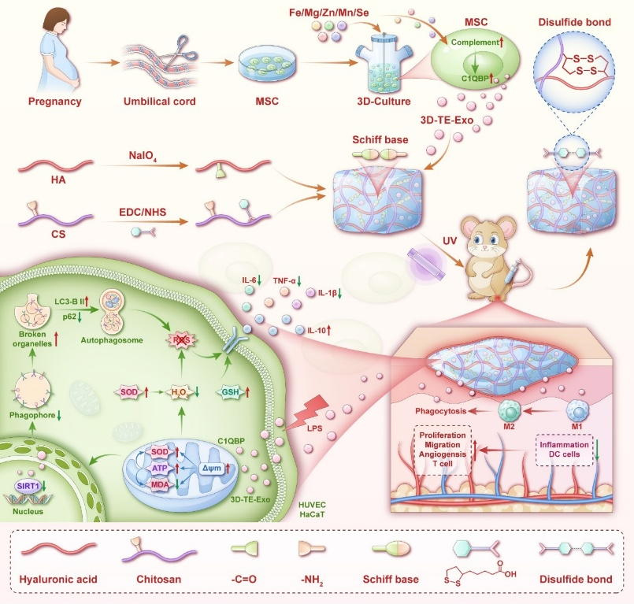

**Figure 1.** The exosomes (3D-TE-Exo) with high activity were constructed by Fe-Mg-Zn-Mn-Se multi-TE synergy and 3D dynamic culture.

**Conclusion/Discussion.** This work establishes a novel paradigm for synergistic design of engineered Exo and smart biomaterials, demonstrating clinical translation potential and pioneering multi-target intervention approach for DFU therapy.

**References:** This work was supported by National Natural Science Foundation of China (82073778, 82104106) and CAMS Innovation Fund for Medical Sciences (CIFMS) (2021-I2M-1-026, China).

(1) Wang S, et al. Adv Sci. 2023;10:e2303167.

(2) Wang S, et al. J Control Release. 2024;369:420–43.