Comparing 3D Printed Polypills for Alopecia Against Compounded Capsules

Jared A. Miles¹, Zheng Zheng¹
School of Pharmacy and Pharmaceutical Sciences, University of Queensland, Brisbane, Queensland, Australia.

Background and aims. Androgenetic alopecia is an inherited disease causing hair loss that impacts life quality and self-esteem. The combination treatment of finasteride and minoxidil has been established as the gold standard for treatment but is currently not commercially available. Currently it can be compounded in capsule form, however with increased attention to 3D-printed personalised medicine in recent years, a 3D printed polypill containing finasteride and minoxidil would fill the gap and help its production. This study aimed to develop and 3D print these tablets, and quality assess them against their compounded capsule equivalents.

Methods. A powder formulation was prepared using Kollidon® VA64 based fast release polymer combined with lactose, pigment, and the drugs finasteride and minoxidil. This formulation was 3D printed using selective laser sintering (SLS) to produce tablets (see Figure 1). Quality assessment of the 3D printed tablets was performed using British Pharmacopoeia standards, including dimensional accuracy and precision (height, diameter, weight), hardness, thermal compatibility using differential scanning calorimetry and thermogravimetric analysis, and drug content and uniformity using high-performance liquid chromatography.

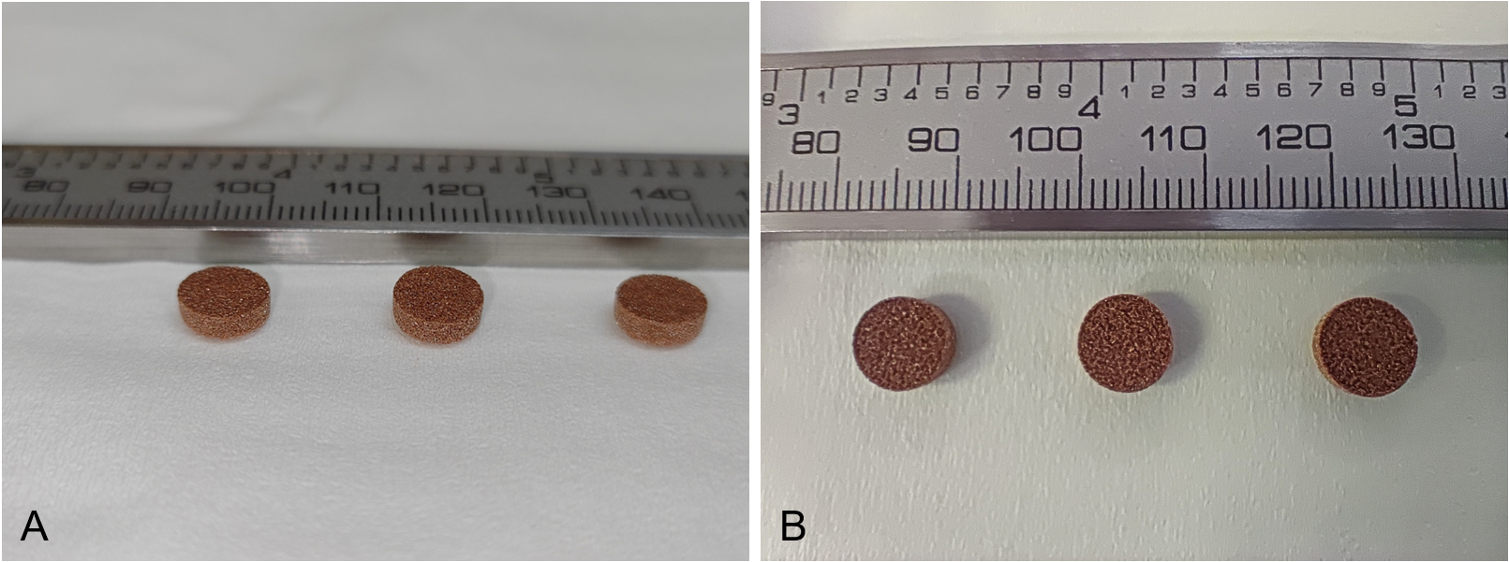
Figure 1: SLS 3D printed finasteride and minoxidil tablets
Results. SLS 3D printed tablets demonstrated less than 1% dimensional variation, and less than 2% weight deviation, complying with quality standards from British Pharmacopeia. Notably, the hardness test showed an average of 67 N, falling into the compressed tablet hardness range. Drug content assays revealed SLS 3D printed polypills had less than 4% dosage deviation of both drugs, outperforming compounded capsules targeting the same dosage. As expected, SLS 3D printed tablets showed immediate drug release, with both drugs reaching 75% release within 30 minutes.

Conclusion/Discussion. This study showcases capability of SLS 3D printing to accurately and precisely produce polypills, highlighting its promising future in personalised medicine and compounding pharmacy.

