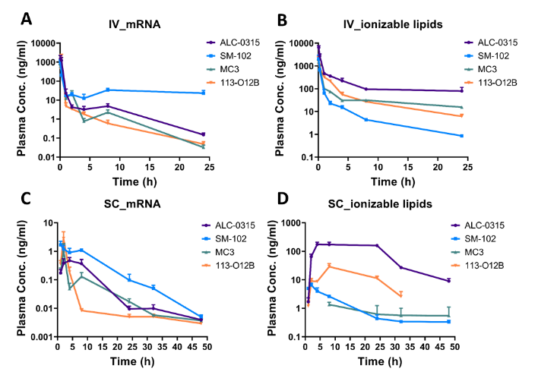
Ionizable lipid effects on mRNA-LNP pharmacokinetics and biodistribution
Yuxiang Ren¹, Angus Johnston¹, Natalie Trevaskis¹
¹Monash University, Melbourne, VIC, Australia

Introduction. Ionizable lipids play a crucial role in mRNA-lipid nanoparticle (LNP) formulations by facilitating mRNA encapsulation, promoting cell uptake, and enhancing endosomal escape of mRNA-LNPs. Despite their importance in mRNA delivery, the specific effects of ionizable lipids on mRNA-LNP in vivo pharmacokinetics (PK) and biodistribution remain underexplored.
Aims. This study aims to examine the effect of SM-102, ALC-0315, DLin-MC3-DMA (MC3), and 113-O12B ionizable lipids in mRNA-LNP formulations on plasma PK of lipid and mRNA, and biodistribution of expressed protein following SC and IV administration in mice.
Methods. mRNA-LNP formulations incorporating each ionizable lipid were constructed with nLuc-GFP mRNA and administered via SC or IV injection in mice. Plasma samples were collected over time to assess mRNA and lipid levels using RT-qPCR and LC-MS/MS, while tissue samples were analyzed for protein expression using AMI HT.
Results. Altering ionizable lipids markedly affected plasma PK of both mRNA and LNP lipids, as well as tissue biodistribution of expressed protein. SM-102 LNPs showed the highest plasma stability and mRNA bioavailability (~3-fold higher than others after SC injection). ALC-0315 LNPs produced prolonged lipid exposure but lower mRNA plasma levels compared to SM-102 across both routes. MC3 LNPs displayed the longest terminal half-life and delayed mRNA expression. After IV dosing, protein expression localized mainly to the liver, whereas SC dosing yielded higher expression in skin and draining lymph nodes.
Discussion. Despite differences in PK, SM-102 and ALC-0315 LNPs achieved similar overall tissue protein expression, suggesting the mRNA in LNP in plasma at early timepoints is more available for expression. The distinct biodistribution following SC versus IV administration highlights how route and lipid choice jointly shape therapeutic outcomes.

