Arterial stiffness shows stronger association with cognitive function in females than males
Genevieve Shek¹, Elza Plotz², Charlene Melencion², Andy Lee², Arthiga Vickneswaran², Katherine Samaras^{1,2}, Audrey Adji^{1,3,4}. St Vincent’s School of Clin Med, UNSW¹, Sydney, NSW; Garvan Institute of Med Research, Sydney, NSW; Cardiology, St Vincent’s Hosp³, Sydney, NSW; MCSR Lab, Victor Chang Cardiac Research Institute⁴, Sydney, NSW.

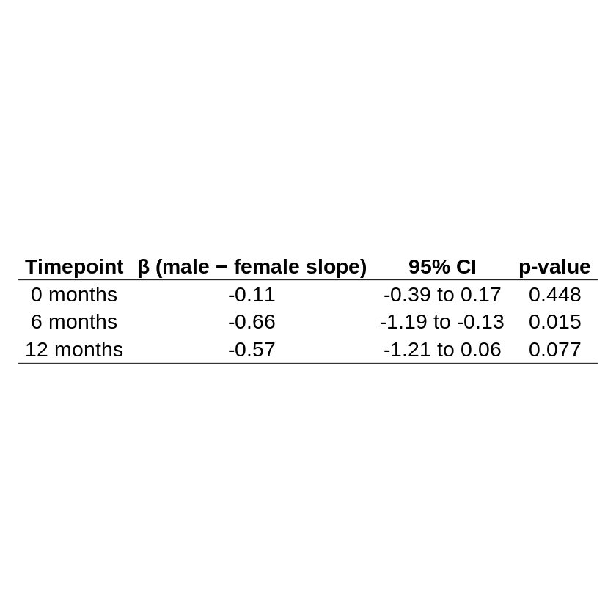
Introduction. Arterial stiffness increases with age, transmitting higher pulse pressures to cerebral microvasculature and potentially accelerating cognitive decline. Postmenopausal arterial stiffening may contribute to faster cognitive deterioration and higher dementia rates in females.
Aims. To examine the association between carotid-femoral pulse wave velocity (cfPWV, a marker of arterial stiffness) and cognition, measured using Montreal Cognitive Assessment (MoCA), in older adults with mild cognitive impairment.
Methods. Data were obtained from 255 participants (130 males, 125 females; MoCA <26) in the MetMemory Study, a 3-year randomised, double-blind, placebo-controlled trial of metformin. Mean ± SD age was 71.7±6.6 years and BMI 29.7±4.9 kg/m². BP, cfPWV (SphygmoCor XCEL) assessments and MoCA were conducted at 0, 6, and 12 months. Sex differences were evaluated at baseline using two-sample t-tests. Linear regression models assessed the relationship between cfPWV and MoCA, including sex-stratified and interaction analyses.
Results. Females had lower BMI (28.7±4.8kg/m²) and diastolic ((77 ± 9mmHg) brachial, (78 ± 9mmHg) central) pressure than males (all p<0.001). Across the whole cohort, higher cfPWV was associated with lower MoCA scores at 0 (p < 0.001) and 12 months (p=0.005). Sex-stratified analyses revealed this association was significant only in females at 0 (n=115, p=0.003), 6 months (n=104, p=0.013), and 12 months (n=109, p=0.004). A cfPWV×Sex interaction revealed a stronger association between cfPWV and MoCA in females than males, reaching significance at 6 months (Table).
Discussion. Increased arterial stiffness is more strongly associated with lower cognitive function in females than males. This could reflect greater cerebral vulnerability from higher central haemodynamic load and lower diastolic perfusion. These findings reinforce the importance of sex-specific approaches to vascular ageing and dementia prevention.

