**A Bioprinted Placental Organoid Model for Pregnancy Research and Preeclampsia Drug Screening**

**Claire I Richards1,2**, Hao Chen3, Ashley Bannister1, Matthew O’Rourke3, Matthew Padula1, David Gallego Ortega4,5,6, Amy Bottomley7, Louise Cole7, Lana McClements1,2.

School of Life Sciences, Faulty of Science, University of Technology Sydney1, Sydney, NSW, Australia;

Institute for Biomedical Materials and Devices, Faulty of Science, University of Technology Sydney 2, Sydney, NSW, Australia;

Centre for Inflammation, Centenary Institute and School of Life Sciences, Faculty of Science, University of Technology Sydney3, Sydney, NSW, Australia;

School of Biomedical Engineering, Faculty of Engineering and Information Technology, University of Technology Sydney4, Sydney, NSW, Australia;

Garvan Institute of Medical Research, The Kinghorn Cancer Centre5, Sydney, NSW, Australia

School of Clinical Medicine, Faculty of Medicine, University of New South Wales6, Sydney, NSW, Australia;

Microbial Imaging Facility at the Australian Institute for Microbiology and Infection, Faculty of Science, University of Technology Sydney7, Sydney, NSW, Australia.

**Background and aims.** Preeclampsia is a dangerous pregnancy condition without a cure, caused by placental dysfunction. Placental organoids offer a new experimental model of placental development for therapeutic testing (1). However, most organoid cultures rely on Matrigel which varies between batches and cannot be tuned for composition and stiffness (2). We aimed to compare Matrigel-embedded and bioprinted placental organoids in terms of biology and treatment response.

**Methods.** ACH-3P trophoblast cells were embedded in Matrigel or bioprinted in a polyethylene glycol (PEG)-based matrix using a RASTRUM platform (Inventia Life Science) for up to 12 days. Organoid formation and growth were captured by live cell imaging and viability analysed by Alamar Blue assay. Organoids were harvested for analysis of trophoblast differentiation by confocal microscopy, single cell RNA sequencing and proteomics (LC-MS/MS). Drug screening was performed by stimulating organoids with tumour necrosis factor (TNF; 20ng/mL) and treating with either aspirin (0.5mM) or metformin (0.5mM). Live cell imaging and fluorescent labelling was used to assess organoid growth and viability.

**Results.** Cells encapsulated within the Matrigel and PEG matrix self-formed organoids within 2-3 days and demonstrated invasive properties (Fig 1a). The presence of key trophoblast subtypes was confirmed by immunofluorescence labelling for markers E-cadherin, HLA-G and β-hCG (Fig 1b). Single cell RNA sequencing and proteomics revealed bioprinted organoids favored extravillous trophoblast differentiation and Matrigel-derived organoids favored the syncytiotrophoblast subtype (Fig 1c). While there was no significant impact on organoid number or size with TNF treatment, mean organoid size was significantly reduced with TNF + aspirin (p=0.01) and TNF + metformin (p=0.045) co-treatments.

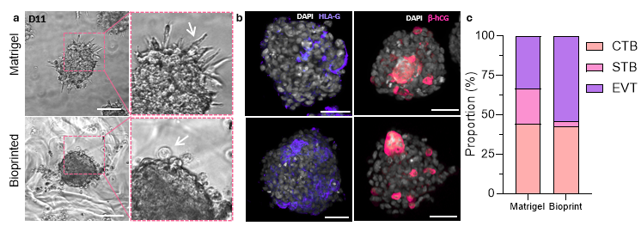

**Figure 1.** (a) Brightfield images of Matrigel-embedded and bioprinted ACH-3P organoids at day 11 of culture. (B) Immunofluorescence images of Matrigel and bioprinted ACH-3P organoids labelled for HLA-G (purple) and β-hCG (pink) alongside DAPI (grey). (C) Proportion of cytotrophoblast (CTB), syncytiotrophoblast (STB) and extravillous trophoblast (EVT) subtypes in Matrigel and bioprinted organoids according to scRNAseq analysis. Scale bar = 100 µm.

**Conclusion/Discussion.** Here, we present a novel approach to placental organoid generation using highly tunable and reproducible synthetic hydrogels. This study highlights the importance of matrix selection in animal-free models and the potential for high throughput screening of treatments targeting placental dysfunction.

**References:**

1. Turco, M.Y., Gardner, L., Kay, R.G. et al. Trophoblast organoids as a model for maternal–fetal interactions during human placentation. Nature 564, 263–267 (2018).
2. Kozlowski, M.T., Crook, C.J. & Ku, H.T. Towards organoid culture without Matrigel. *Commun Biol* **4**, 1387 (2021). https://doi.org/10.1038/s42003-021-02910-8