**Development of enteric polymer based tofacitinib citrate pellets via continuous manufacturing using hot melt extrusion technology**

Young Soo Woo1, Seung Yeob Baeg1, Ju Yeon Park1, Hyun Jong Park1, Dong Wuk Kim1

1College of Pharmacy and Research Institute of Pharmaceutical Sciences, Kyungpook National University, Daegu 41566, Republic of Korea

**Background and aims.** This study aimed to develop enteric pellets of tofacitinib citrate (TFC), a therapeutic agent for ulcerative colitis, using a hot-melt extrusion (HME)-based continuous manufacturing process. Unlike conventional systemic formulations, this approach focused on local drug delivery to the intestine (pH ≥ 6.8) to enhance therapeutic efficacy while reducing systemic side effects.

**Methods.** TFC was blended with various enteric polymers and plasticizers, then processed via twin-screw extrusion (Haake miniCTW, Thermo Fisher Scientific) to produce six pellet formulations (F1–F6). The pellets were evaluated for drug content, dissolution behavior, and physicochemical properties. Additionally, a three-month stability study was conducted under accelerated conditions (45 °C and 75% relative humidity), and in vivo evaluation was performed in rats to assess pharmacokinetic profiles and intestinal targeting efficiency.

**Results.** Drug content analysis confirmed uniform active ingredient distribution across all formulations, with F2 (96.9 ± 1.12%), F3 (97.7 ± 0.52%), and F5 (99.5 ± 1.77%) showing excellent uniformity. Dissolution testing under simulated gastric (pH 1.2) and intestinal (pH 6.8) conditions demonstrated <10% release at pH 1.2, confirming enteric protection. F2 exhibited optimal sustained release at pH 6.8. Physicochemical analyses, including TGA, XRD, FT-IR, SEM, and DSC, indicated thermal stability, maintained crystallinity, polymer-drug compatibility, and homogeneous dispersion post-HME.

Additional results from the ongoing stability study and in vivo evaluation will be presented in the full presentation.

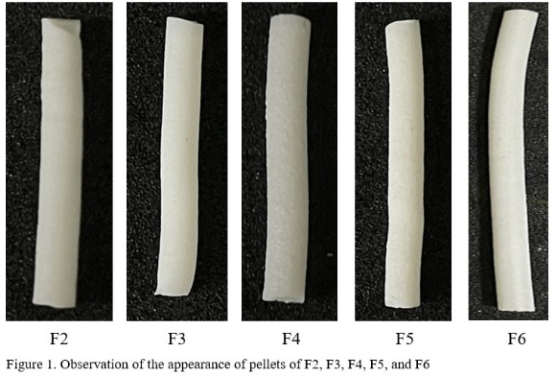 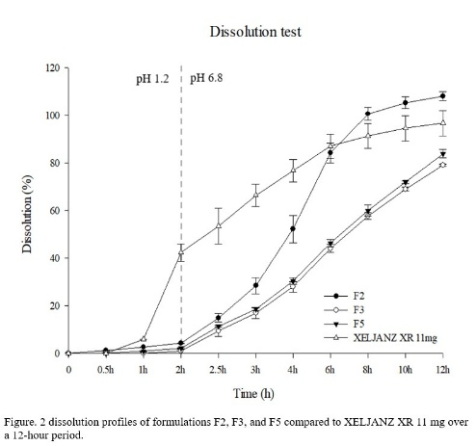

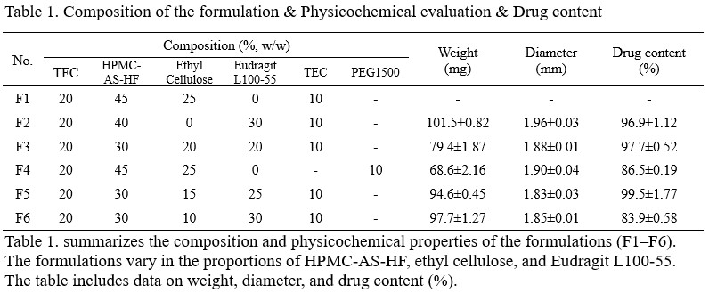

**Conclusion/Discussion.** This study demonstrates the feasibility of producing TFC enteric pellets via an HME-based continuous manufacturing platform. Among the tested formulations, F2 was identified as optimal based on uniformity, enteric resistance, sustained drug release, and stability. The findings support the potential of this approach for targeted treatment of ulcerative colitis, providing a basis for further clinical development.

**Acknowledgements:** This work was supported by the National Research Foundation of Korea (NRF) grants funded by the Korean government (No. 2020R1A5A2017323 and No. 2021R1C1C1010721).