Development of a 3D-Printed Medicated Straw Formulation for Pediatric and Geriatric Patients
Kampanart Huanbutta¹, Kittipat Suwanpitak², Tanikan Sangnim².
Department of Manufacturing Pharmacy, College of Pharmacy, Rangsit University, Muang, Pathum Thani, Thailand;
Department of Pharmaceutical Technology, Faculty of Pharmaceutical Sciences, Burapha University, Muang, Chonburi, Thailand.

Background and aims. Non-compliance with medication remains a critical challenge in both pediatric and geriatric populations, with dysphagia (difficulty in swallowing) being a major contributing factor that can compromise therapeutic outcomes. This study aims to address this issue by developing an innovative pharmaceutical delivery system “a medicated straw” using 3D printing (Figure 1) combined with lyophilization technology.

Methods. The research involved a systematic approach starting with the design and simulation of a straw capable of delivering solid dosage forms conveniently via liquid sipping. A Design of Experiments (DOE) framework was applied using the Box-Behnken design to optimize formulation parameters and investigate their effects on the final tablet characteristics. Key variables examined included the water-to-solid content ratio, the ratio of Explotab® to mannitol, and gelatin concentration.

Results. Partial Least Squares (PLS) regression analysis revealed that the water-to-solid content ratio significantly impacted crucial tablet features such as sipping time, pore volume, density, and weight loss. The Explotab®:mannitol ratio primarily influenced the drug dissolution rate, while gelatin content was found to be the most significant factor affecting tablet hardness. An optimal formulation was identified with a water:solid content ratio of 4.918, an Explotab®:mannitol ratio of 0.075, and a gelatin concentration of 0.225 mg per unit. These parameters yielded a robust, easy-to-use medicated straw suitable for individuals with swallowing difficulties, offering a patient-friendly alternative for drug administration in vulnerable age groups.
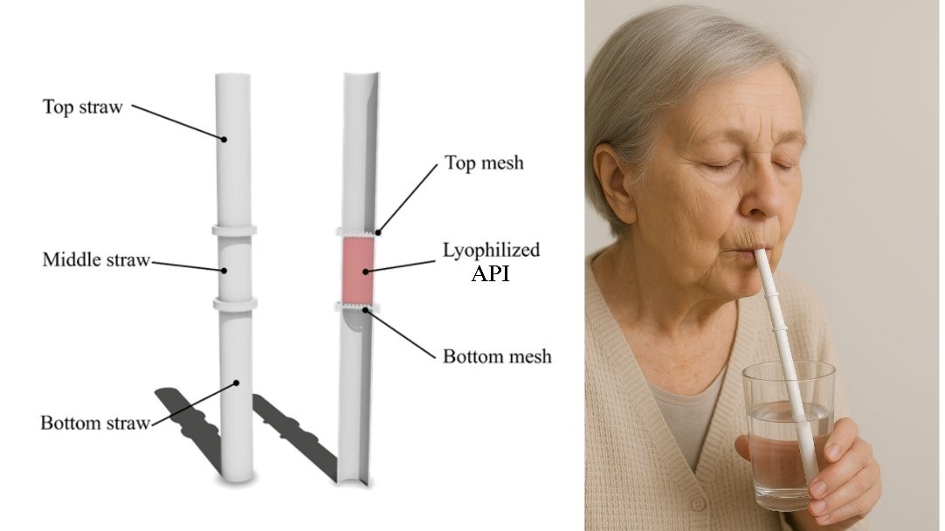

Figure 1. Schematic and application of a 3D-printed medicated straw for dysphagia patients.

Conclusion/Discussion. This study demonstrates the potential of combining 3D printing and lyophilization technologies to create customized, effective drug delivery systems that enhance medication adherence in populations most at risk of non-compliance.

References:
(1) Huanbutta, K. et al (2023). Pharmaceutics, 15(7):1877.
(2) Rawat, S. et al (2023). Expert Opin Drug Deliv, 20(3):313–314.

