Where are my mob at? Analysing the representation of Australian Indigenous pharmacists
Jared A Miles^{1,2}, Tasneem Mahomedy¹, Meng-Wong Taing¹. School of Pharmacy, The University of Queensland¹, Woolloongabba, QLD, Australia; Poche Centre for Indigenous Health², The University of Queensland, St Lucia, QLD, Australia.
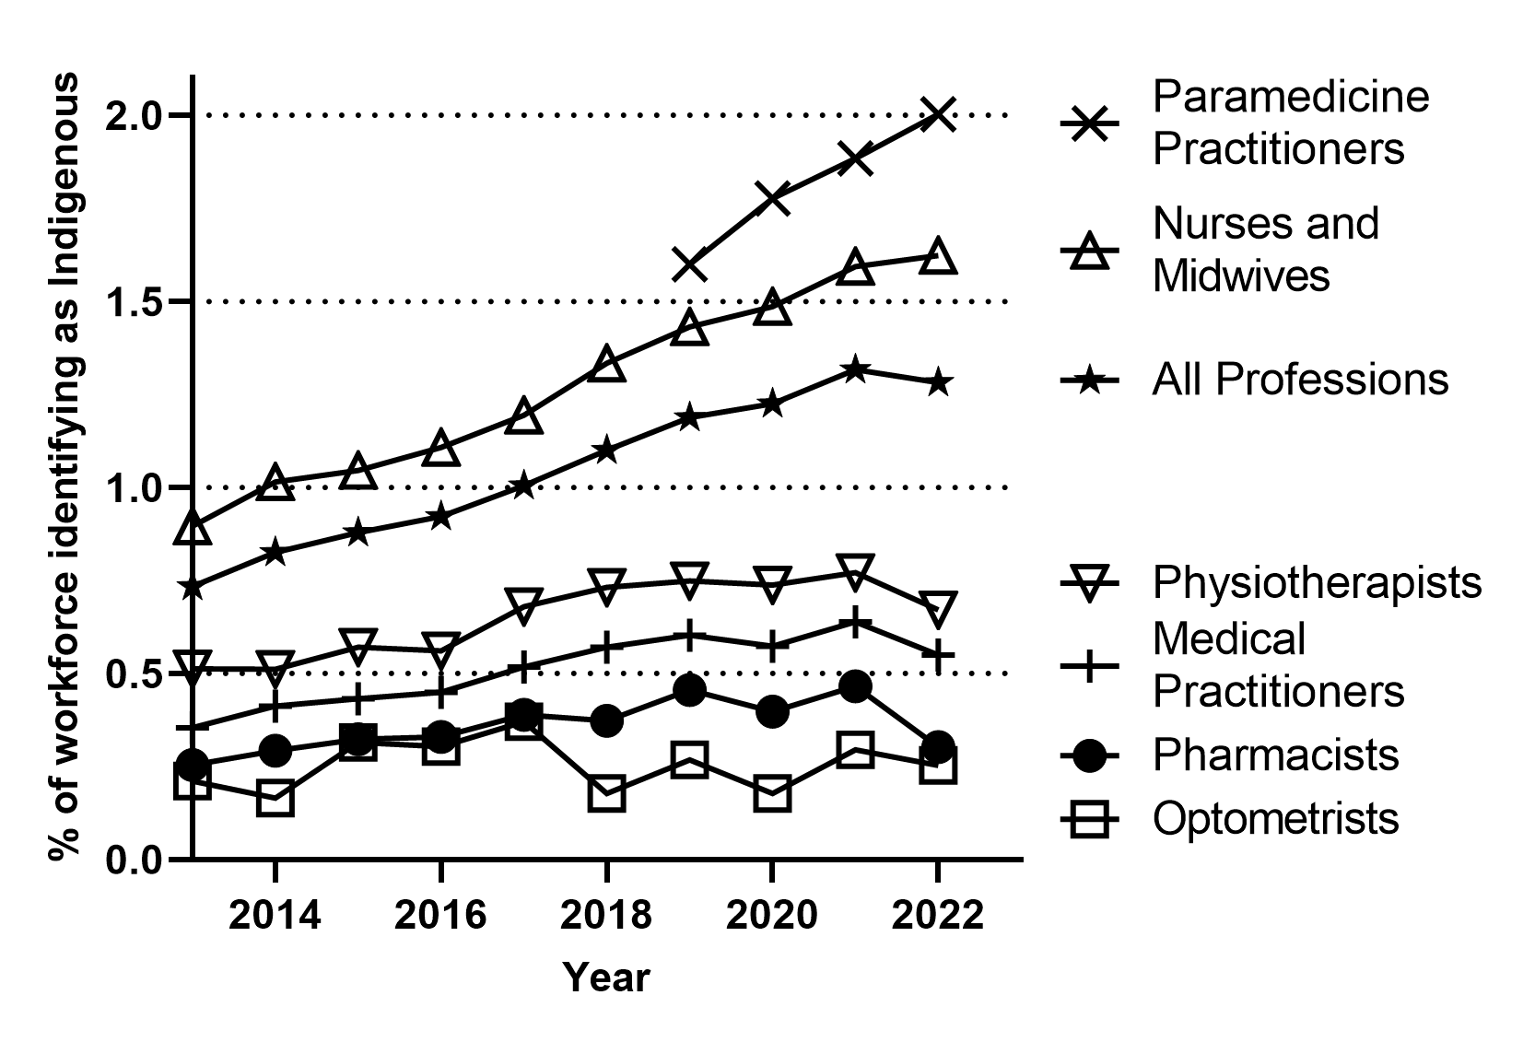
Introduction. Despite comprising approximately 3% of the national population, Australian First Nations peoples remain underrepresented in the health workforce. Increasing representation is a key step to improving culturally safe healthcare.
Aims. This study aims to understand trends in the demographics of registered pharmacists in Australia who identify as Aboriginal and/or Torres Strait Islander, compare these with other health professions, and identify potential professional and societal factors that have impacted their representation.
Methods. Analysis was primarily performed using the National Health Workforce Dataset spanning 2013-2022, supported by data from the Pharmacy Board of Australia and other professional organisations.
Results. As of 2023 there are 118 Australian First Nations registered pharmacists, constituting only 0.3% of the pharmacist workforce. This is the lowest representation in the profession since 2014. Further analysis of representation across demographics, professional roles, and geographical locations will be presented.
Discussion. All registered health professions underrepresent First Nations peoples; however, pharmacists are the second lowest despite the ease of access and visibility to the public. Some of this may be related to post-COVID attrition of the workforce, but it is clear that a profession-wide approach is necessary to attract and train more First Nations pharmacists and to improve retention towards developing cultural capacity and safety in pharmacy.

